|  |  |
| --- | --- |
| **EXERCISE NO:1**  **DATE:09/01/2025** | **RGB TO GRAY**  **HISTOGRAM EQUILIZATION**  **IMAGE RESIZING** |

**AIM:**

To view the rgb image to grayscale image and histogram equilization of the grayscale image and the image resizing

**LENA IMAGE**

**ALGORITHM:**

1. Importing the library function of the open cv for image processing
2. Read the image using the imread function
3. Convert the image using function of the cvtColor in BGR to RGB
4. Execute the image
5. After the image is convert into the GRAY color using the function cvt Color in RGB to GRAY
6. Manuval code of the RGB to gray scale
7. Histogram equilization and using the RAVEL function and calculating the histogram using the CALC HIST and also the manuval code of the histogram equilization using the table
8. After that the resizing the image using the function resize

**CODE:**

import cv2

import numpy as np

import matplotlib.pyplot as plt

img1 = cv2.imread(r"lena.png")

img3 = cv2.cvtColor(img1,cv2.COLOR_BGR2RGB)

img_2 = cv2.cvtColor(img3,cv2.COLOR_RGB2GRAY)

plt.figure(figsize=(6,5))

plt.subplot(121)

plt.title("lena in rgb")

plt.imshow(img3)

**OUTPUT:**

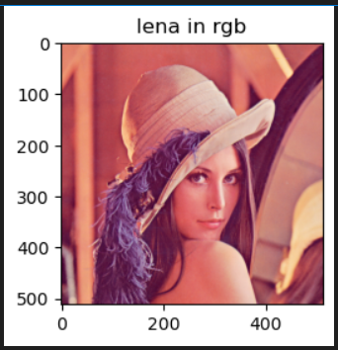

**CODE:**

import cv2

import numpy as np

import matplotlib.pyplot as plt

plt.figure(figsize=(4,2))

plt.subplot(121)

plt.title("grayimage")

plt.imshow(img_2 , cmap='gray')

red,green,blue = img1[:,:,0],img1[:,:,1],img1[:,:,2]

gamma=1

gray=0.299*red**gamma+0.587*green**gamma+0.114*blue**gamma

print(gray)

plt.figure(figsize=(4,5))

plt.subplot(121)

plt.imshow(gray,cmap='gray')

**OUTPUT:**

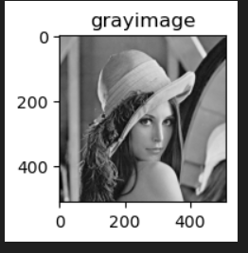f

The grayscale image output

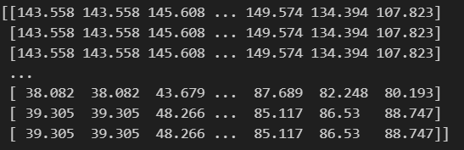

The manuval code of the the grayscale image



**HISTOGRAM EQUALIZATION PLOT USING THE LIBRARIES AND THE MANUVAL**

**CODE:**

import cv2

import numpy as np

import matplotlib.pyplot as plt

img_hist=cv2.calcHist([img1],[0],None,[256],[0,256])

plt.subplot(222)

plt.title("histogram")

plt.plot(img_hist)

final_image =cv2.equalizeHist(img_2)

res=np.hstack((gray,final_image))

plt.imshow(res,cmap='gray')

histg = cv2.calcHist([img_2],[0],None,[256],[0,256])

plt.plot(histg)

plt.hist(img_2.ravel(),256,[0,256])

plt.hist(img1.ravel(),256,[0,256])

**MANUVAL CODE:**

def manual_histogram_equalization(image):

    if len(image.shape) == 3:

        image = cv2.cvtColor(image, cv2.COLOR_BGR2GRAY)

    hist, bins = np.histogram(image.flatten(), 256, [0, 256])

    cdf = hist.cumsum()

    cdf_normalized = cdf * hist.max() / cdf.max()

    cdf_m = np.ma.masked_equal(cdf, 0)

    cdf_m = (cdf_m - cdf_m.min()) * 255 / (cdf_m.max() - cdf_m.min())

    cdf = np.ma.filled(cdf_m, 0).astype('uint8')

    img_equalized = cdf[image]  #

    return img_equalized

img1 = cv2.imread(r"lena.png")

if img1 is None:

    print("Error: Image not loaded. Check the file path.")

else:

    img_equalized = manual_histogram_equalization(img1)

    plt.figure(figsize=(10, 5))

    # Original Image

    plt.subplot(1, 2, 1)

    plt.imshow(cv2.cvtColor(img1, cv2.COLOR_BGR2RGB))

    plt.title('Original Image')

    plt.axis('off')

    # Equalized Image

    plt.subplot(1, 2, 2)

    plt.imshow(cv2.cvtColor(img_equalized, cv2.COLOR_BGR2RGB))

    plt.title('Histogram Equalized Image')

    plt.axis('off')

    plt.show()\

**HISTOGRAM CODE:**

import cv2

import numpy as np

import matplotlib.pyplot as plt

img = cv2.imread(r"lena.png")

if img is None:

    print("Error: Image not loaded. Check the file path.")

else:

    gray_img = cv2.cvtColor(img, cv2.COLOR_BGR2GRAY)

    hist = cv2.calcHist([gray_img], [0], None, [256], [0, 256])

    plt.figure(figsize=(10, 5))

    plt.title('Histogram of Grayscale Image')

    plt.xlabel('Pixel Intensity')

    plt.ylabel('Frequency')

    plt.plot(hist)

    plt.xlim([0, 256])

    plt.show()

**OUTPUT:**

**Using libraries output**

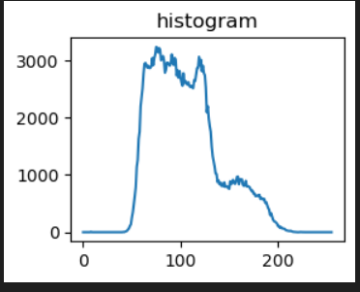

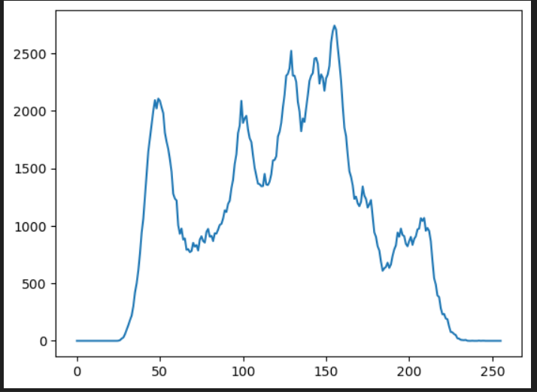

**Histogram equalize output**

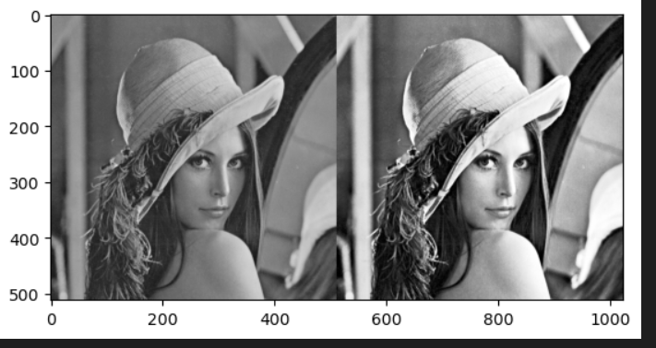

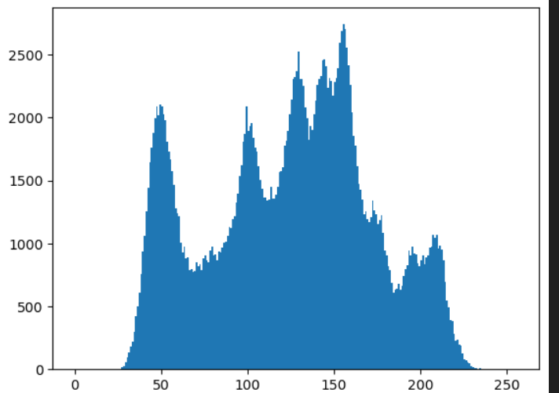

**Histogram output of example 1 :**

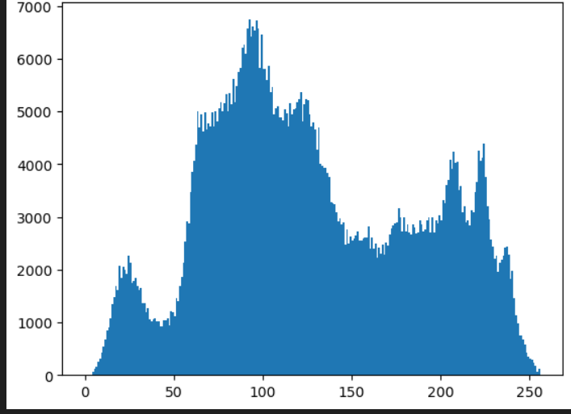

**Histogram equalize output of manuval :**

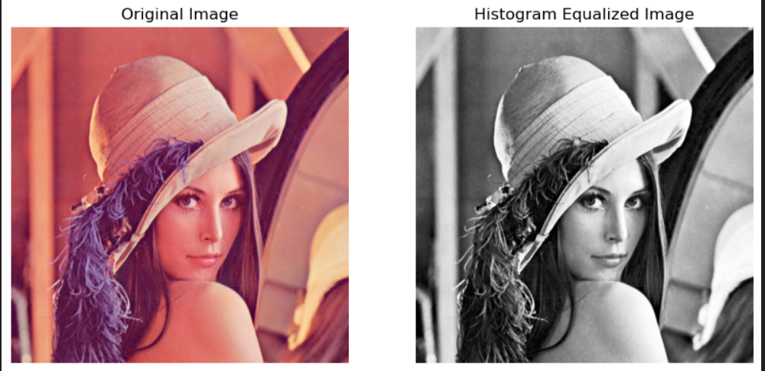

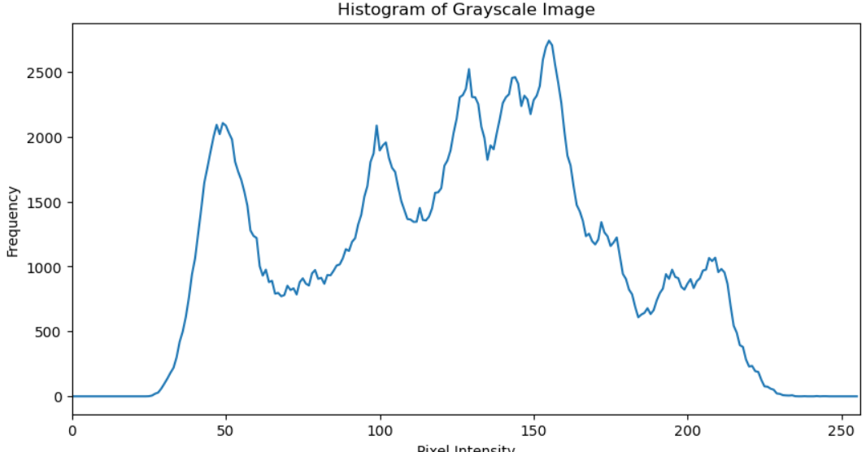

**RESIZING THE IMAGE**

**CODE:**

import cv2

import numpy as np

import matplotlib.pyplot as plt

resized_image = cv2.resize(img_2, (1000, 1000))

plt.imshow(img_2,cmap='grey')

plt.figure(figsize=(10,10))

plt.subplot(121)

plt.imshow(resized_image,cmap='grey')

plt.title("resize image")

**OUTPUT:**

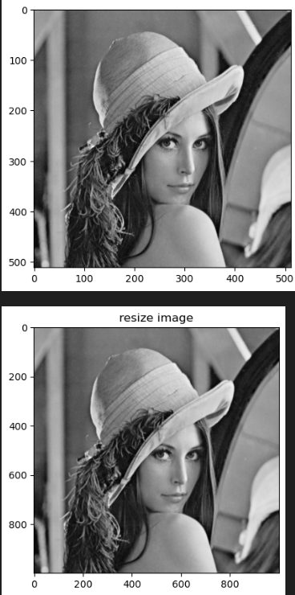

**SUNG IMAGE**

**ALGORITHM:**

1. Importing the library function of the open cv for image processing
2. Read the image using the imread function
3. Convert the image using function of the cvtColor in BGR to RGB
4. Execute the image
5. After the image is convert into the GRAY color using the function cvt Color in RGB to GRAY
6. Manuval code of the RGB to gray scale
7. Histogram equilization and using the RAVEL function and calculating the histogram using the CALC HIST and also the manuval code of the histogram equilization using the table
8. After that the resizing the image using the function resize

**CODE:**

import cv2

import numpy as np

import matplotlib.pyplot as plt

img1 = cv2.imread(r"SUNG.png")

img3 = cv2.cvtColor(img1,cv2.COLOR_BGR2RGB)

img_2 = cv2.cvtColor(img3,cv2.COLOR_RGB2GRAY)

plt.figure(figsize=(6,5))

plt.subplot(121)

plt.title("lena in rgb")

plt.imshow(img3)

**OUTPUT:**

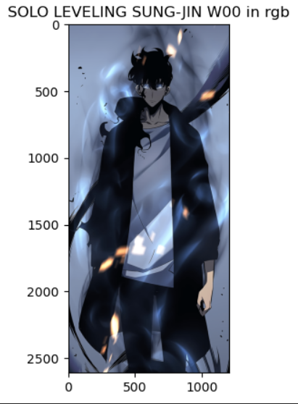

**CODE:**

import cv2

import numpy as np

import matplotlib.pyplot as plt

plt.figure(figsize=(4,2))

plt.subplot(121)

plt.title("grayimage")

plt.imshow(img_2 , cmap='gray')

red,green,blue = img1[:,:,0],img1[:,:,1],img1[:,:,2]

gamma=1

gray=0.299*red**gamma+0.587*green**gamma+0.114*blue**gamma

print(gray)

plt.figure(figsize=(4,5))

plt.subplot(121)

plt.imshow(gray,cmap='gray')

**OUTPUT:**

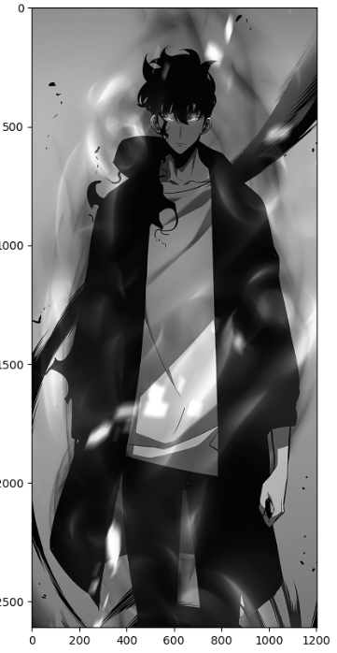

The grayscale image output

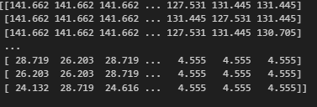

The manuval code of the the grayscale image



**HISTOGRAM EQUALIZATION PLOT USING THE LIBRARIES AND THE MANUVAL**

**CODE:**

import cv2

import numpy as np

import matplotlib.pyplot as plt

img_hist=cv2.calcHist([img1],[0],None,[256],[0,256])

plt.subplot(222)

plt.title("histogram")

plt.plot(img_hist)

final_image =cv2.equalizeHist(img_2)

res=np.hstack((gray,final_image))

plt.imshow(res,cmap='gray')

histg = cv2.calcHist([img_2],[0],None,[256],[0,256])

plt.plot(histg)

plt.hist(img_2.ravel(),256,[0,256])

plt.hist(img1.ravel(),256,[0,256])

**MANUVAL CODE:**

def manual_histogram_equalization(image):

    if len(image.shape) == 3:

        image = cv2.cvtColor(image, cv2.COLOR_BGR2GRAY)

    hist, bins = np.histogram(image.flatten(), 256, [0, 256])

    cdf = hist.cumsum()

    cdf_normalized = cdf * hist.max() / cdf.max()

    cdf_m = np.ma.masked_equal(cdf, 0)

    cdf_m = (cdf_m - cdf_m.min()) * 255 / (cdf_m.max() - cdf_m.min())

    cdf = np.ma.filled(cdf_m, 0).astype('uint8')

    img_equalized = cdf[image]  #

    return img_equalized

img1 = cv2.imread(r"SUNG.png")

if img1 is None:

    print("Error: Image not loaded. Check the file path.")

else:

    img_equalized = manual_histogram_equalization(img1)

    plt.figure(figsize=(10, 5))

    # Original Image

    plt.subplot(1, 2, 1)

    plt.imshow(cv2.cvtColor(img1, cv2.COLOR_BGR2RGB))

    plt.title('Original Image')

    plt.axis('off')

    # Equalized Image

    plt.subplot(1, 2, 2)

    plt.imshow(cv2.cvtColor(img_equalized, cv2.COLOR_BGR2RGB))

    plt.title('Histogram Equalized Image')

    plt.axis('off')

    plt.show()\

**HISTOGRAM CODE:**

import cv2

import numpy as np

import matplotlib.pyplot as plt

img = cv2.imread(r"SUNG.png")

if img is None:

    print("Error: Image not loaded. Check the file path.")

else:

    gray_img = cv2.cvtColor(img, cv2.COLOR_BGR2GRAY)

    hist = cv2.calcHist([gray_img], [0], None, [256], [0, 256])

    plt.figure(figsize=(10, 5))

    plt.title('Histogram of Grayscale Image')

    plt.xlabel('Pixel Intensity')

    plt.ylabel('Frequency')

    plt.plot(hist)

    plt.xlim([0, 256])

    plt.show()

**OUTPUT:**

**Using libraries output**

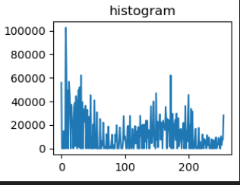

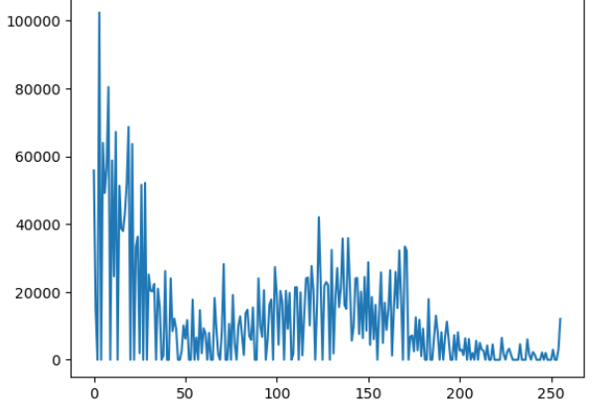

**Histogram equalize output**

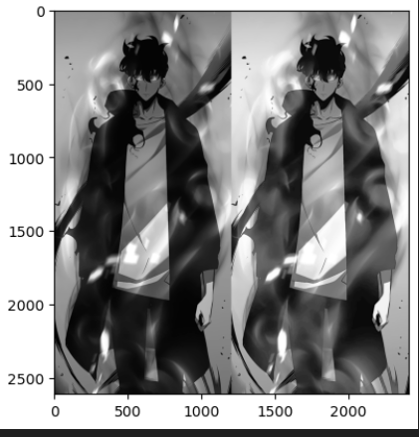

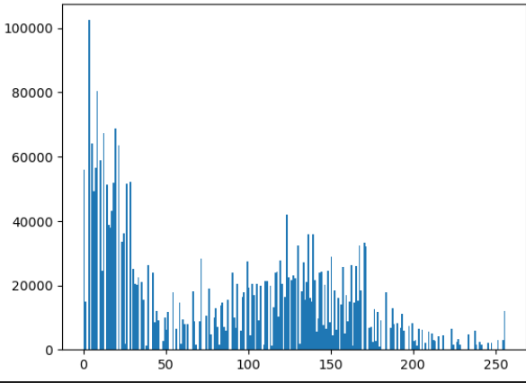

**Histogram output of example 1 :**

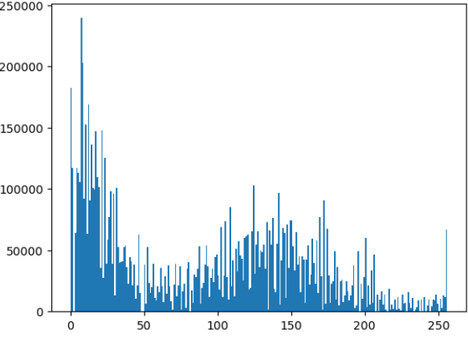

**Histogram equalize output of manuval :**

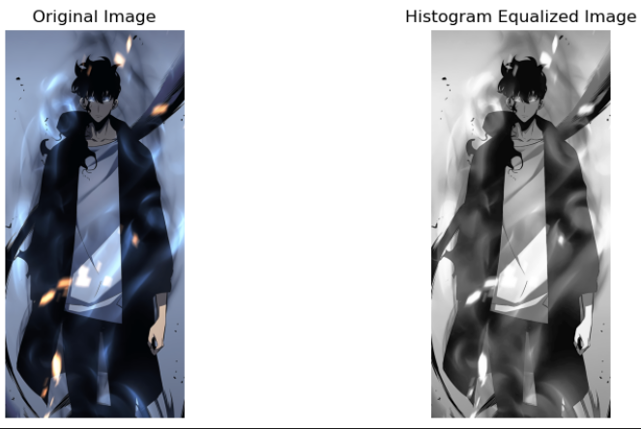

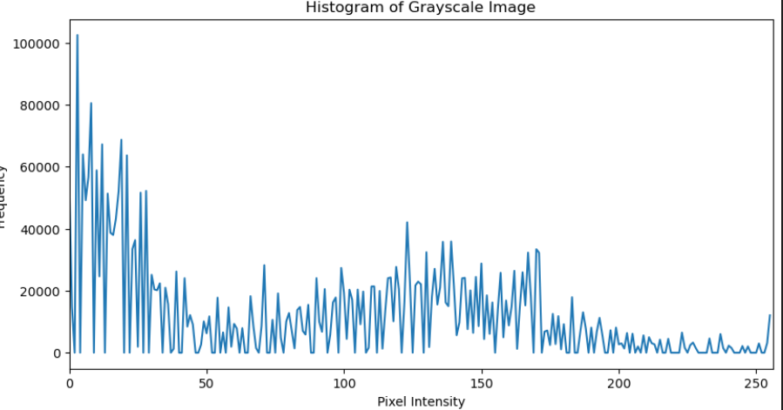

**RESIZING THE IMAGE**

**CODE:**

import cv2

import numpy as np

import matplotlib.pyplot as plt

resized_image = cv2.resize(img_2, (3000, 5000))

plt.imshow(img_2,cmap='grey')

plt.figure(figsize=(10,10))

plt.subplot(121)

plt.imshow(resized_image,cmap='grey')

plt.title("resize image")

**OUTPUT:**

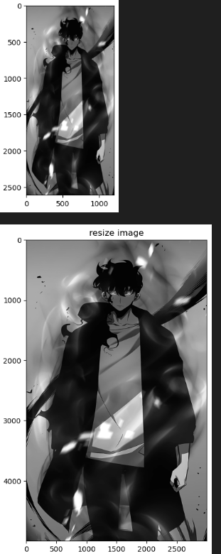

**RESULT:**

**We have successfully executed basic image and functions to reize image histogram equilization and RGB to GRAY for lena and sung image**

|  |  |
| --- | --- |
| **EXERCISE NO:2**  **DATE:22/01/2025** | **COLOR MODELS** |

**AIM:**

To view the HSV image and CMY image of the color models and also of the extraction of the image in the different view and also the check saturation

and the empty matrix

**HOME PIC**

**ALGORITHM:**

1. Importing the library function of the open cv for image processing
2. Read the image using the imread function
3. Convert the image using function of the cvtColor in BGR to RGB
4. Execute the image
5. After the image is convert into the RGB color using the function cvt Color
6. Code of the RGB to the HSV and print the hue ,saturation and value separately to see the difference
7. Code of the RGB to the CMY and print the cryan ,magenta and value separately to see the difference
8. Check the difference of the pic
9. And the empty matrix and display the colour of the rgb and cmy

**CODE:**

import cv2

import matplotlib.pyplot as plt

import numpy as np

image = cv2.imread("Downloads/bilioniare.jpg")

image_rgb = cv2.cvtColor(image,cv2.COLOR_BGR2RGB)

plt.imshow(image_rgb)

plt.axis('off')

plt.title('Original image')

plt.show()

**OUTPUT:**

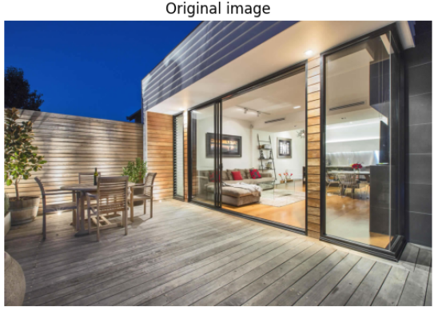

**CODE:**

rgb= image_rgb/255.0

cmy=1-rgb

cmy_image = (cmy*255).astype(np.uint8)

plt.imshow(cmy_image)

plt.axis('off')

plt.title('CMY Image')

plt.show()

**OUTPUT:**

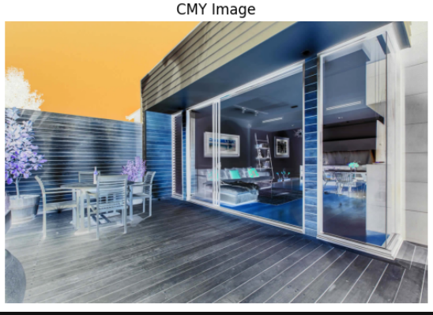

**CODE:**

hsv_image = cv2.cvtColor(image_rgb,cv2.COLOR_RGB2HSV)

plt.imshow(hsv_image)

plt.axis('off')

plt.title('HSV image ')

plt.show()

**OUTPUT:**

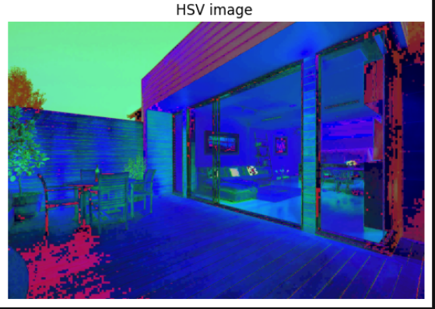

**SPLITING THE CHANNEL SEPARATELY FOR THE HSV AND CMY**

**CODE:**

import cv2

import numpy as np

import matplotlib.pyplot as plt

image_hsv = cv2.cvtColor(image, cv2.COLOR_BGR2HSV)

plt.figure(figsize=(12, 4))

hue = image_hsv[:, :, 0]

hue_colormap = cv2.applyColorMap(hue, cv2.COLORMAP_HSV)

plt.subplot(1, 3, 1)

plt.imshow(hue_colormap)

plt.title('Hue Channel')

plt.axis('off')

sat = image_hsv[:, :, 1]

sat_colormap = cv2.applyColorMap(sat, cv2.COLORMAP_JET)

# Plot the Saturation channel in the second subplot

plt.subplot(1, 3, 2) # 1 row, 3 columns, position 2

plt.imshow(sat_colormap)

plt.title('Saturation Channel')

plt.axis('off')

# ----- Value Channel -----

val = image_hsv[:, :, 2] # Extract the Value channel

# Scale Value to [0, 255] for better visualization

val_colormap = cv2.applyColorMap(val, cv2.COLORMAP_TURBO)

# Plot the Value channel in the third subplot

plt.subplot(1, 3, 3) # 1 row, 3 columns, position 3

plt.imshow(val_colormap)

plt.title('Value Channel')

plt.axis('off')

# Show the plots

plt.tight_layout() # Adjust the spacing between the subplots

plt.show()

**OUTPUT:**

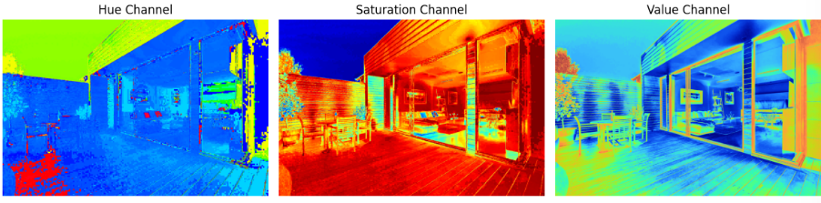

**CODE:**

image_rgb = cv2.cvtColor(image, cv2.COLOR_BGR2RGB)

plt.figure(figsize=(10, 5))

red = image_rgb.copy()

red[:, :, 1] = 0

red[:, :, 2] = 0

plt.subplot(1, 3, 1)

plt.imshow(red)

plt.title('Red Channel')

plt.axis('off')

green = image_rgb.copy()

green[:, :, 0] = 0

green[:, :, 2] = 0

plt.subplot(1, 3, 2)

plt.imshow(green)

plt.title('Green Channel')

plt.axis('off')

blue = image_rgb.copy()

blue[:, :, 0] = 0

blue[:, :, 1] = 0

plt.subplot(1, 3, 3)

plt.imshow(blue)

plt.title('Blue Channel')

plt.axis('off')

plt.tight_layout()

plt.show()

**OUTPUT:**

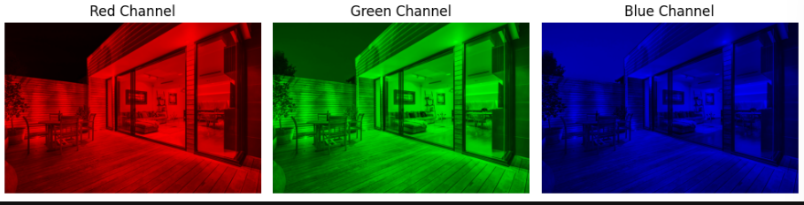

**CHECKING THE HSV AND CMY**

**CODE:**

import cv2

def modify_cmy (image,factor):

rgb= image/255.0

cmy=1-rgb

cmy_image = (cmy*255).astype(np.uint8)

R,G,B = cmy_image[:,:,0],cmy_image[:,:,1],cmy_image[:,:,2]

R =np.clip(R*factor ,0,255)

G = np.clip(G * factor, 0, 255)

B = np.clip(B * factor, 0, 255)

modified_cmy=np.stack([R,G,B],axis=-1).astype(np.uint8)

return modified_cmy

def modify_hsv(image,saturation_factor ):

hsv_image = cv2.cvtColor(image,cv2.COLOR_RGB2HSV).astype(np.float32)

H,S,V= hsv_image[:,:,0],hsv_image[:,:,1],hsv_image[:,:,2]

S=np.clip(S*saturation_factor,0,255)

hsv_image_modified =np.stack([H,S,V],axis=-1).astype(np.uint8)

return hsv_image_modified

modified_cmy_image= modify_cmy( image_rgb, factor=1.2)

modified_hsv_image= modify_hsv( image_rgb,saturation_factor=2)

plt.figure(figsize=(10,10))

plt.subplot(131)

plt.imshow(image_rgb)

plt.title("original image ")

plt.axis("off")

plt.subplot(132)

plt.imshow(modified_cmy_image)

plt.title("cmy ")

plt.axis("off")

plt.subplot(133)

plt.imshow(modified_hsv_image)

plt.title("hsv")

plt.axis("off")

**OUTPUT:**

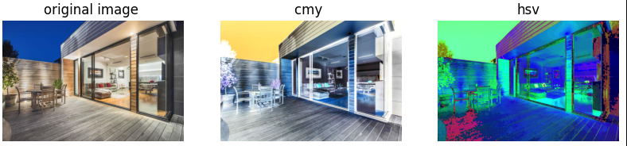

**CODE:**

import cv2

import numpy as np

import matplotlib.pyplot as plt

cmy1= modified_cmy_image

cmy1=cmy1/255.0

rgb2=1-cmy1

rgb=(rgb2*255).astype(np.uint8)

plt.figure(figsize=(100,100))

plt.subplot(131)

plt.imshow(rgb)

plt.title("cmy image ")

plt.axis("off")

**OUTPUT:**

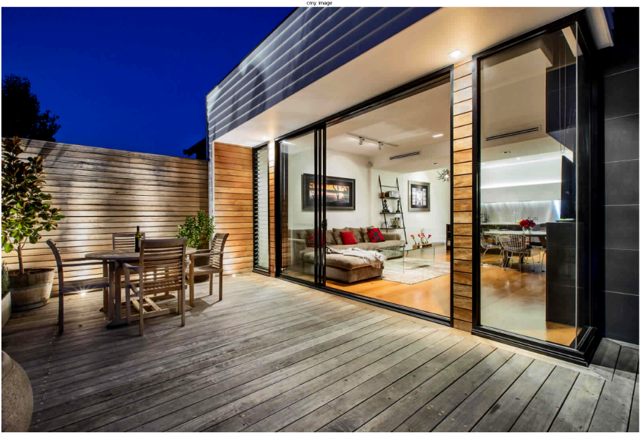

**CODE:**

import cv2

import numpy as np

import matplotlib.pyplot as plt

modified_rgb = cv2.cvtColor(modified_hsv_image, cv2.COLOR_HSV2RGB)

plt.figure(figsize=(100,100))

plt.subplot(131)

plt.imshow(modified_rgb)

plt.title("hsv to rgb image ")

plt.axis("off")

**OUTPUT:**

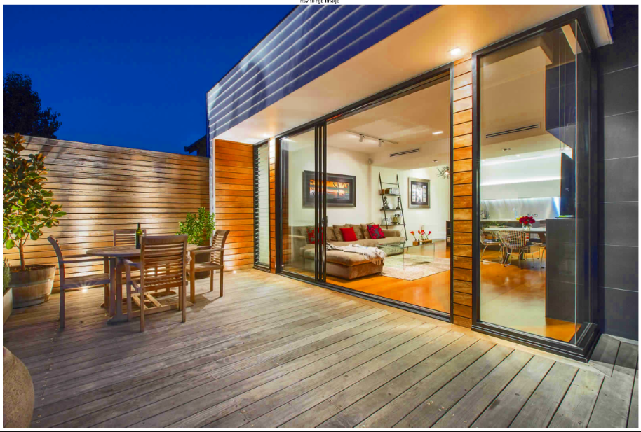

**REEMPTY MATRIX FOR CREATE COLOURS**

**CODE:**

import numpy as np

import matplotlib.pyplot as plt

# Create an empty matrix for an image

# Shape: (height, width, channels)

height, width = 300, 300 # Define image size

blank_image = np.zeros((height, width, 3), dtype=np.uint8) # RGB image initialized to black

# Create colors

# Fill Red channel

red_image = blank_image.copy()

red_image[:, :, 0] = 255 # Set the Red channel to maximum (255)

# Fill Green channel

green_image = blank_image.copy()

green_image[:, :, 1] = 255 # Set the Green channel to maximum (255)

# Fill Blue channel

blue_image = blank_image.copy()

blue_image[:, :, 2] = 255 # Set the Blue channel to maximum (255)

# Combine Red + Green to create Yellow

yellow_image = blank_image.copy()

yellow_image[:, :, 0] = 255 # Red

yellow_image[:, :, 1] = 255 # Green

# Combine Green + Blue to create Cyan

cyan_image = blank_image.copy()

cyan_image[:, :, 1] = 255 # Green

cyan_image[:, :, 2] = 255 # Blue

# Combine Red + Blue to create Magenta

magenta_image = blank_image.copy()

magenta_image[:, :, 0] = 255 # Red

magenta_image[:, :, 2] = 255 # Blue

# Display the results

plt.figure(figsize=(12, 8))

plt.subplot(231)

plt.imshow(red_image)

plt.title("Red")

plt.axis("off")

plt.subplot(232)

plt.imshow(green_image)

plt.title("Green")

plt.axis("off")

plt.subplot(233)

plt.imshow(blue_image)

plt.title("Blue")

plt.axis("off")

plt.subplot(234)

plt.imshow(yellow_image)

plt.title("Yellow (Red + Green)")

plt.axis("off")

plt.subplot(235)

plt.imshow(cyan_image)

plt.title("Cyan (Green + Blue)")

plt.axis("off")

plt.subplot(236)

plt.imshow(magenta_image)

plt.title("Magenta (Red + Blue)")

plt.axis("off")

plt.tight_layout()

plt.show()

**OUTPUT:**

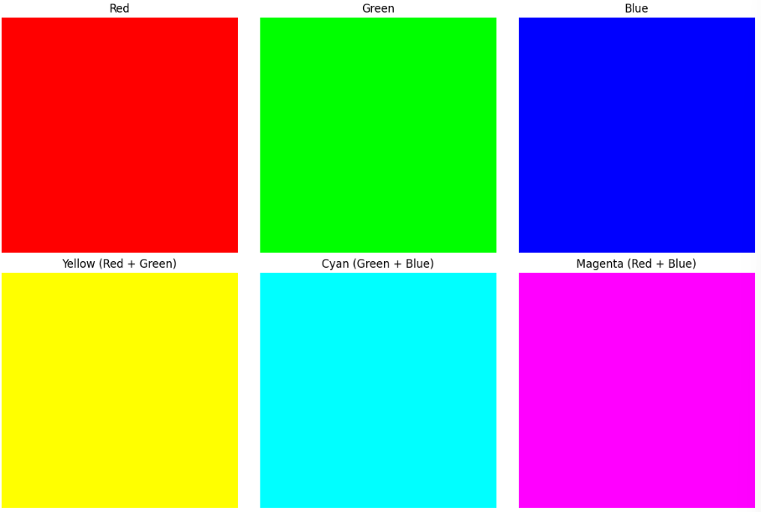

**FREEFIRE PIC**

**ALGORITHM:**

1. Importing the library function of the open cv for image processing
2. Read the image using the imread function
3. Convert the image using function of the cvtColor in BGR to RGB
4. Execute the image
5. After the image is convert into the RGB color using the function cvt Color
6. Code of the RGB to the HSV and print the hue ,saturation and value separately to see the difference
7. Code of the RGB to the CMY and print the cryan ,magenta and value separately to see the difference
8. Check the difference of the pic
9. And the empty matrix and display the colour of the rgb and cmy

**CODE:**

import cv2

import matplotlib.pyplot as plt

import numpy as np

image = cv2.imread("Downloads/ garena-free-fire-4k-v8.jpg")

image_rgb = cv2.cvtColor(image,cv2.COLOR_BGR2RGB)

plt.imshow(image_rgb)

plt.axis('off')

plt.title('Original image')

plt.show()

**OUTPUT:**

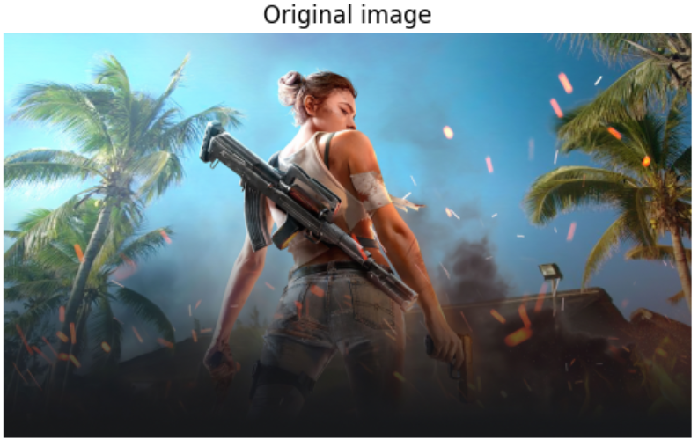

**CODE:**

rgb= image_rgb/255.0

cmy=1-rgb

cmy_image = (cmy*255).astype(np.uint8)

plt.imshow(cmy_image)

plt.axis('off')

plt.title('CMY Image')

plt.show()

**OUTPUT:**

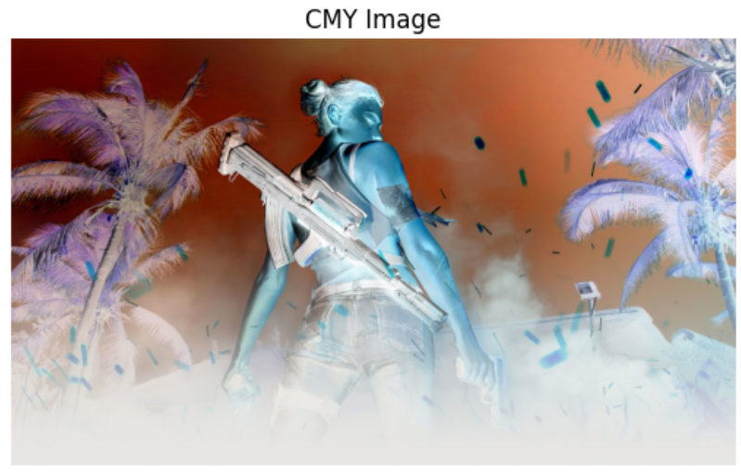

**CODE:**

hsv_image = cv2.cvtColor(image_rgb,cv2.COLOR_RGB2HSV)

plt.imshow(hsv_image)

plt.axis('off')

plt.title('HSV image ')

plt.show()

**OUTPUT:**

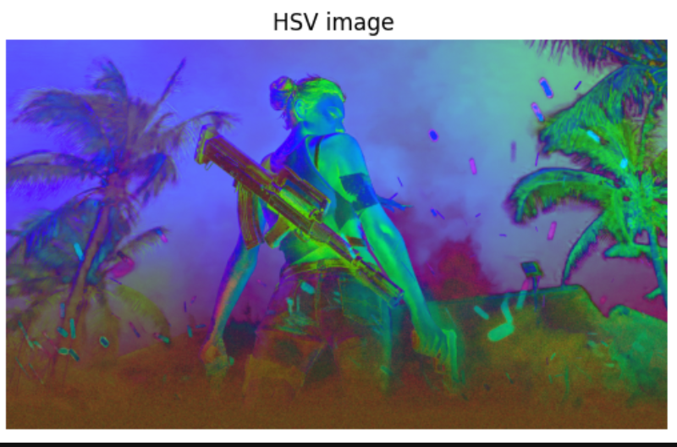

**SPLITING THE CHANNEL SEPARATELY FOR THE HSV AND CMY**

**CODE:**

import cv2

import numpy as np

import matplotlib.pyplot as plt

image_hsv = cv2.cvtColor(image, cv2.COLOR_BGR2HSV)

plt.figure(figsize=(12, 4))

hue = image_hsv[:, :, 0]

hue_colormap = cv2.applyColorMap(hue, cv2.COLORMAP_HSV)

plt.subplot(1, 3, 1)

plt.imshow(hue_colormap)

plt.title('Hue Channel')

plt.axis('off')

sat = image_hsv[:, :, 1]

sat_colormap = cv2.applyColorMap(sat, cv2.COLORMAP_JET)

# Plot the Saturation channel in the second subplot

plt.subplot(1, 3, 2) # 1 row, 3 columns, position 2

plt.imshow(sat_colormap)

plt.title('Saturation Channel')

plt.axis('off')

# ----- Value Channel -----

val = image_hsv[:, :, 2] # Extract the Value channel

# Scale Value to [0, 255] for better visualization

val_colormap = cv2.applyColorMap(val, cv2.COLORMAP_TURBO)

# Plot the Value channel in the third subplot

plt.subplot(1, 3, 3) # 1 row, 3 columns, position 3

plt.imshow(val_colormap)

plt.title('Value Channel')

plt.axis('off')

# Show the plots

plt.tight_layout() # Adjust the spacing between the subplots

plt.show()

**OUTPUT:**

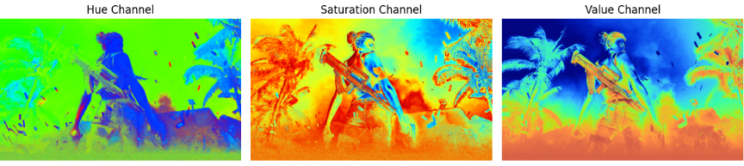

**CODE:**

image_rgb = cv2.cvtColor(image, cv2.COLOR_BGR2RGB)

plt.figure(figsize=(10, 5))

red = image_rgb.copy()

red[:, :, 1] = 0

red[:, :, 2] = 0

plt.subplot(1, 3, 1)

plt.imshow(red)

plt.title('Red Channel')

plt.axis('off')

green = image_rgb.copy()

green[:, :, 0] = 0

green[:, :, 2] = 0

plt.subplot(1, 3, 2)

plt.imshow(green)

plt.title('Green Channel')

plt.axis('off')

blue = image_rgb.copy()

blue[:, :, 0] = 0

blue[:, :, 1] = 0

plt.subplot(1, 3, 3)

plt.imshow(blue)

plt.title('Blue Channel')

plt.axis('off')

plt.tight_layout()

plt.show()

**OUTPUT:**

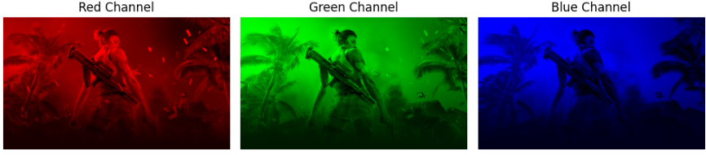

**CHECKING THE HSV AND CMY**

**CODE:**

import cv2

def modify_cmy (image,factor):

rgb= image/255.0

cmy=1-rgb

cmy_image = (cmy*255).astype(np.uint8)

R,G,B = cmy_image[:,:,0],cmy_image[:,:,1],cmy_image[:,:,2]

R =np.clip(R*factor ,0,255)

G = np.clip(G * factor, 0, 255)

B = np.clip(B * factor, 0, 255)

modified_cmy=np.stack([R,G,B],axis=-1).astype(np.uint8)

return modified_cmy

def modify_hsv(image,saturation_factor ):

hsv_image = cv2.cvtColor(image,cv2.COLOR_RGB2HSV).astype(np.float32)

H,S,V= hsv_image[:,:,0],hsv_image[:,:,1],hsv_image[:,:,2]

S=np.clip(S*saturation_factor,0,255)

hsv_image_modified =np.stack([H,S,V],axis=-1).astype(np.uint8)

return hsv_image_modified

modified_cmy_image= modify_cmy( image_rgb, factor=1.2)

modified_hsv_image= modify_hsv( image_rgb,saturation_factor=2)

plt.figure(figsize=(10,10))

plt.subplot(131)

plt.imshow(image_rgb)

plt.title("original image ")

plt.axis("off")

plt.subplot(132)

plt.imshow(modified_cmy_image)

plt.title("cmy ")

plt.axis("off")

plt.subplot(133)

plt.imshow(modified_hsv_image)

plt.title("hsv")

plt.axis("off")

**OUTPUT:**

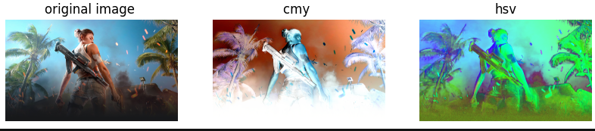

**CODE:**

import cv2

import numpy as np

import matplotlib.pyplot as plt

cmy1= modified_cmy_image

cmy1=cmy1/255.0

rgb2=1-cmy1

rgb=(rgb2*255).astype(np.uint8)

plt.figure(figsize=(100,100))

plt.subplot(131)

plt.imshow(rgb)

plt.title("cmy image ")

plt.axis("off")

**OUTPUT:**

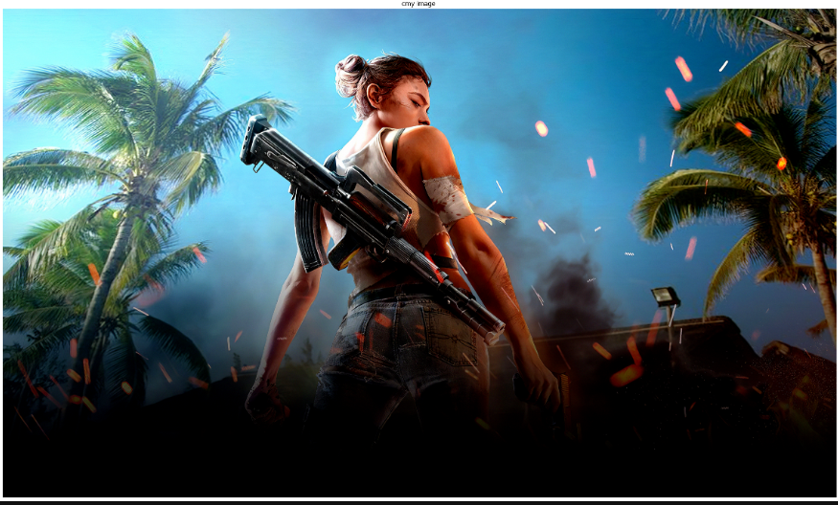

**CODE:**

import cv2

import numpy as np

import matplotlib.pyplot as plt

modified_rgb = cv2.cvtColor(modified_hsv_image, cv2.COLOR_HSV2RGB)

plt.figure(figsize=(100,100))

plt.subplot(131)

plt.imshow(modified_rgb)

plt.title("hsv to rgb image ")

plt.axis("off")

**OUTPUT:** 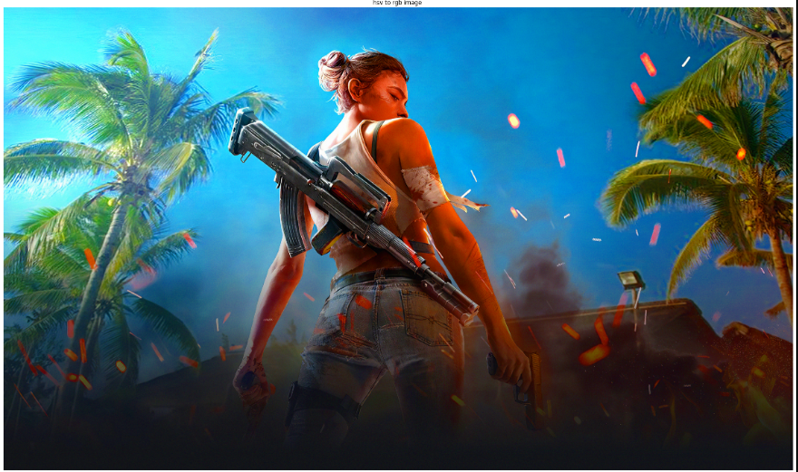

**REEMPTY MATRIX FOR CREATE COLOURS**

**CODE:**

import numpy as np

import matplotlib.pyplot as plt

# Create an empty matrix for an image

# Shape: (height, width, channels)

height, width = 300, 300 # Define image size

blank_image = np.zeros((height, width, 3), dtype=np.uint8) # RGB image initialized to black

# Create colors

# Fill Red channel

red_image = blank_image.copy()

red_image[:, :, 0] = 255 # Set the Red channel to maximum (255)

# Fill Green channel

green_image = blank_image.copy()

green_image[:, :, 1] = 255 # Set the Green channel to maximum (255)

# Fill Blue channel

blue_image = blank_image.copy()

blue_image[:, :, 2] = 255 # Set the Blue channel to maximum (255)

# Combine Red + Green to create Yellow

yellow_image = blank_image.copy()

yellow_image[:, :, 0] = 255 # Red

yellow_image[:, :, 1] = 255 # Green

# Combine Green + Blue to create Cyan

cyan_image = blank_image.copy()

cyan_image[:, :, 1] = 255 # Green

cyan_image[:, :, 2] = 255 # Blue

# Combine Red + Blue to create Magenta

magenta_image = blank_image.copy()

magenta_image[:, :, 0] = 255 # Red

magenta_image[:, :, 2] = 255 # Blue

# Display the results

plt.figure(figsize=(12, 8))

plt.subplot(231)

plt.imshow(red_image)

plt.title("Red")

plt.axis("off")

plt.subplot(232)

plt.imshow(green_image)

plt.title("Green")

plt.axis("off")

plt.subplot(233)

plt.imshow(blue_image)

plt.title("Blue")

plt.axis("off")

plt.subplot(234)

plt.imshow(yellow_image)

plt.title("Yellow (Red + Green)")

plt.axis("off")

plt.subplot(235)

plt.imshow(cyan_image)

plt.title("Cyan (Green + Blue)")

plt.axis("off")

plt.subplot(236)

plt.imshow(magenta_image)

plt.title("Magenta (Red + Blue)")

plt.axis("off")

plt.tight_layout()

plt.show()

**OUTPUT:**



**RESULT:**

We have successfully executed basic of the color and using emprty to create colour image

|  |  |
| --- | --- |
| **EXERCISE NO:3**  **DATE:13/02/2025** | **IMAGE TRANSFORMATION** |

**BILLIONAIRE IMAGE:**

**ALGORITHM:**

1. Import OpenCV and necessary libraries
2. Read Image → cv2.imread()
3. Convert BGR to RGB → cv2.cvtColor(image, cv2.COLOR_BGR2RGB)
4. Display Original Image

#### Image Transformations

1. Translation → Shift image using pixel offsets (bx, by)
2. Rotation → Rotate image by a defined angle using a transformation matrix
3. Scaling → Resize image using scale factors (sx, sy)
4. Shearing → Apply shear transformation along x and y axes
5. Reflection → Compute horizontal, vertical, and diagonal flips
6. Display Transformed Images using matplotlib

**CODE:**

import cv2

import matplotlib.pyplot as plt

import numpy as np

image = cv2.imread("billionaire1.jpg")

image_rgb = cv2.cvtColor(image,cv2.COLOR_BGR2RGB)

plt.imshow(image_rgb)

plt.title('Original Image')

plt.axis('off')

plt.show()

**OUTPUT:**

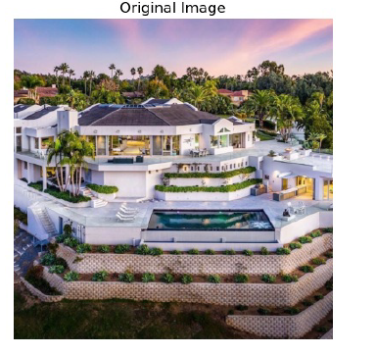

**IMAGE TRANSLATION**

**CODE:**

rows,cols,channels= image_rgb.shape

bx=47

by=47

translated_image=np.zeros_like(image)

for y in range(cols):

for x in range(rows):

new_x=x+bx

new_y=y+bx

if 0<=new_x<cols and 0<=new_y<rows:

translated_image[new_y,new_x]=image_rgb[y,x]

plt.imshow(translated_image)

plt.axis("off")

plt.title("translated Image")

plt.show()

**OUTPUT:**

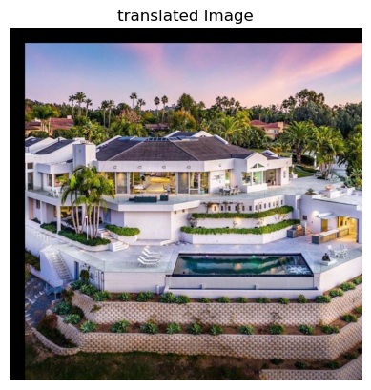

**IMAGE ROTATION:**

**CODE:**

rows,cols,channels=image_rgb.shape

rotated_image=np.zeros_like(image_rgb)

angle=10

angle_rad=np.radians(angle)

rotated_matrix=np.array([[np.cos(angle_rad),-np.sin(angle_rad)],[np.sin(angle_rad),np.cos(angle_rad)]])

cx,cy=cols//2,rows//2

for y in range(rows):

for x in range(cols):

tx,ty=x-cx,y-cy

new_tx,new_ty=np.dot(rotated_matrix ,np.array([tx,ty]))

new_x,new_y = int(new_tx + cx),int(new_ty + cy)

if 0<=new_x<cols and 0<=new_y<rows:

rotated_image[new_y,new_x] = image_rgb[y,x]

plt.imshow(rotated_image)

plt.axis('off')

plt.title('Rotated Image')

plt.show()

**OUTPUT:**

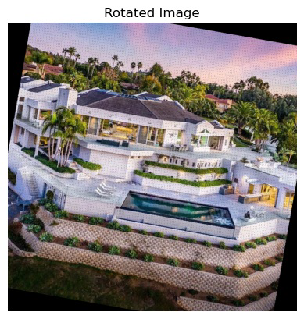

**IMAGE SCALING:**

**CODE:**

sx ,sy = 2.5,1.0

scaled_image = np.zeros_like(image_rgb)

cx ,cy = cols//2,rows//2

for y in range(rows):

for x in range(cols):

tx , ty = x - cx , y - cy

new_tx,new_ty = tx * sx,ty * sy

new_x,new_y = int(new_tx + cx),int(new_ty + cy)

if 0<=new_x<cols and 0<=new_y<rows:

scaled_image[new_y,new_x] = image_rgb[y,x]

plt.imshow(scaled_image)

plt.axis('off')

plt.title('Scaled Image')

plt.show()

**OUTPUT:**

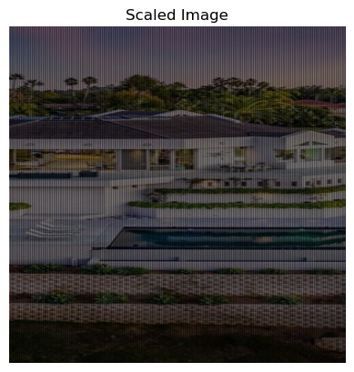

**IMAGE SHEAR:**

**CODE:**

shear_x, shear_y = 0.25, 0.25 # Shear in the x direction

sheared_image = np.zeros_like(image_rgb)

# Find the center of the image

cx, cy = cols // 2, rows // 2

for y in range(rows):

for x in range(cols):

tx, ty = x - cx, y - cy

new_tx = tx + shear_x * ty # Apply shear in x direction

new_ty = ty + shear_y * tx # Apply shear in y direction

new_x, new_y = int(new_tx + cx), int(new_ty + cy)

# Ensure the new coordinates are within bounds

if 0 <= new_x < cols and 0 <= new_y < rows:

sheared_image[new_y, new_x] = image_rgb[y, x]

plt.imshow(sheared_image)

plt.axis('off')

plt.title('Sheared Image')

plt.show()

**OUTPUT:**

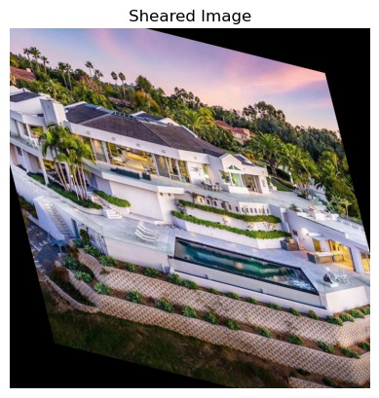

**IMAGE REFLECTION:**

**CODE:**

horizontal_reflection = np.zeros_like(image_rgb)

vertical_reflection = np.zeros_like(image_rgb)

diagonal_reflection = np.zeros_like(image_rgb)

# Perform Manual Reflection

for y in range(rows):

for x in range(cols):

# Horizontal Flip (Mirror Left to Right)

horizontal_reflection[y, x] = image_rgb[y, cols - x - 1]

# Vertical Flip (Mirror Top to Bottom)

vertical_reflection[y, x] = image_rgb[rows - y - 1, x]

# Diagonal Flip (Both Axes)

diagonal_reflection[y, x] = image_rgb[rows - y - 1, cols - x - 1]

plt.figure(figsize=(10, 5))

plt.subplot(1, 4, 1)

plt.imshow(image_rgb)

plt.axis('off')

plt.title("Original Image")

plt.subplot(1, 4, 2)

plt.imshow(horizontal_reflection)

plt.axis('off')

plt.title("Horizontal Reflection")

plt.subplot(1, 4, 3)

plt.imshow(vertical_reflection)

plt.axis('off')

plt.title("Vertical Reflection")

plt.subplot(1, 4, 4)

plt.imshow(diagonal_reflection)

plt.axis('off')

plt.title("Diagonal Reflection")

plt.show()

**OUTPUT:**

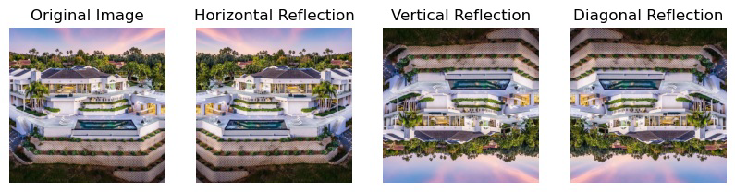

**RESULT:**

We have successfully executed the code…

|  |  |
| --- | --- |
| **EXERCISE NO:4**  **DATE:06/02/2025** | **IMAGE FILTERING** |

**AIM:**

To implement various image processing techniques using OpenCV, including image reading, color space conversions, histogram equalization, manual grayscale conversion, histogram calculation, and image resizing, to enhance and analyze images effectively.

**NATURE IMAGE**

**ALGORITHM:**

1. Import OpenCV and necessary libraries
2. Read Image → cv2.imread()
3. Convert BGR to RGB → cv2.cvtColor(image, cv2.COLOR_BGR2RGB)
4. Display RGB Image
5. Convert RGB to Grayscale → cv2.cvtColor(image, cv2.COLOR_RGB2GRAY)
6. Manual RGB to Grayscale Conversion → Compute weighted sum of channels
7. Histogram Equalization
8. Using cv2.equalizeHist()
9. Compute manually using CDF table
10. Histogram Calculation
11. Using np.ravel() and cv2.calcHist()
12. Resize Image → cv2.resize(image, (width, height))

**CODE:**

import cv2

import matplotlib.pyplot as plt

import numpy as np

image = cv2.imread("Downloads/cv2.jpg")

image_rgb= cv2.cvtColor(image,cv2.COLOR_BGR2RGB)

plt.title("original image")

plt.imshow (image_rgb)

plt.axis ("off")

plt.show ()

**OUTPUT:**

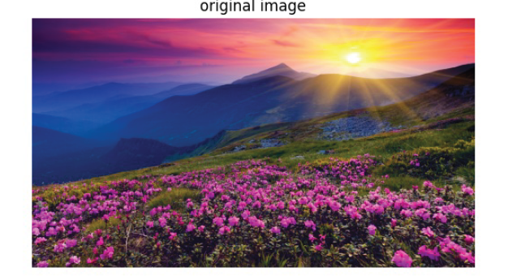

**CODE:**

image_gray = cv2.cvtColor(image,cv2.COLOR_BGR2GRAY)

plt.title("Original Image")

plt.imshow(image_gray,cmap='gray')

plt.axis('off')

plt.show()

**OUTPUT:**

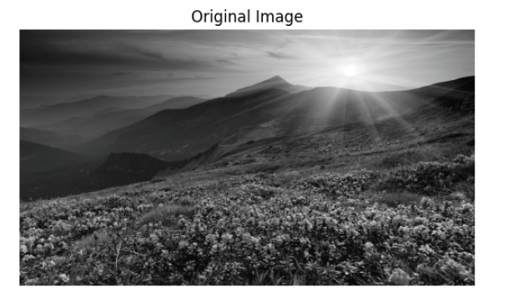

**IMAGE FILTERING:**

**CODE:**

def apply_filter(image, filter_mask):

if len(image.shape) == 3:

image = np.mean(image, axis=2)

image_height, image_width = image.shape

filter_height, filter_width = filter_mask.shape

pad_height, pad_width = filter_height // 2, filter_width // 2

padded_image = np.pad(image, ((pad_height, pad_height), (pad_width, pad_width)), mode='constant', constant_values

filtered_image = np.zeros_like(image, dtype=float)

for i in range(image_height):

for j in range(image_width):

region = padded_image[i:i + filter_height, j:j + filter_width]

filtered_image[i, j] = np.sum(region * filter_mask)

filtered_image = np.clip(filtered_image, 0, 255).astype(np.uint8)

return filtered_image

def median_filter(image, kernel_size=3):

assert kernel_size % 2 == 1

height, width = image.shape

pad = kernel_size // 2

padded_image = np.pad(image, pad, mode='constant', constant_values=0)

filtered_image = np.zeros_like(image)

# Apply median filtering

for i in range(height):

for j in range(width):

neighborhood = padded_image[i:i+kernel_size, j:j+kernel_size]

filtered_image[i, j] = np.median(neighborhood)

return filtered_image

#box_blur_filter = np.ones((5, 5)) / 25

mask_size = 25

box_blur_filter=np.ones((mask_size,mask_size),np.float32)/(mask_size*mask_size)

sharpening_filter = np.array([[ 0, -1, 0],

[-1, 5, -1],

[ 0, -1, 0]], dtype=np.float32)

# Apply sharpening filter to grayscale image

sharpened_image = apply_filter(image_gray, sharpening_filter)

smoothed_image_box = apply_filter(image_gray, box_blur_filter)

smoothed_image_median = median_filter(image_gray, kernel_size=25)

plt.figure(figsize=(12, 8))

plt.subplot(2, 3, 1)

plt.title("Original Image")

plt.imshow(image_gray, cmap='gray')

plt.axis('off')

plt.subplot(2, 3, 2)

plt.title("Smoothing (Box Blur)")

plt.imshow(smoothed_image_box,cmap='gray')

plt.axis('off')

plt.subplot(2, 3, 3)

plt.title("Sharpening Image (Laplacian)")

plt.imshow(sharpened_image, cmap='gray')

plt.axis('off')

plt.subplot(2, 3, 4)

plt.title("Smoothing (Median Filter)")

plt.imshow(smoothed_image_median, cmap='gray')

plt.axis('off')

plt.tight_layout()

plt.show()

**OUTPUT:**

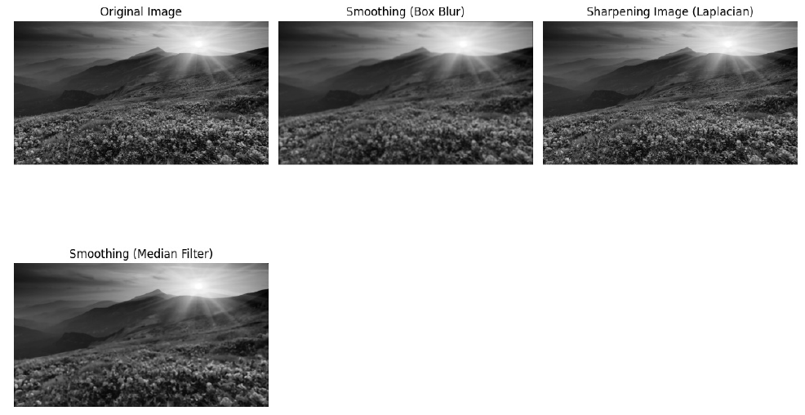

**CODE:**

plt.figure(figsize=(8, 4))

plt.subplot(2,3,1)

plt.hist(image_gray.ravel(),bins=256,range=(0,256),color='maroon')

plt.title("Original Image Histogram")

plt.xlabel("Pixel Values")

plt.ylabel("Frequency")

plt.subplot(2,3,2)

plt.hist(sharpened_image.ravel(),bins=256,range=(0,256),color='maroon')

plt.title("Sharpened Image Histogram")

plt.xlabel("Pixel Values")

plt.ylabel("Frequency")

plt.subplot(2,3,3)

plt.hist(smoothed_image_box.ravel(),bins=256,range=(0,256),color='maroon')

plt.title("Smoothed Box Image Histogram")

plt.xlabel("Pixel Values")

plt.ylabel("Frequency")

plt.subplot(2,3,4)

plt.hist(smoothed_image_median.ravel(),bins=256,range=(0,256),color='maroon')

plt.title("Median Filtered(Smoothed) Image Histogram")

plt.xlabel("Pixel Values")

plt.ylabel("Frequency")

plt.tight_layout()

plt.show()

**OUTPUT:**

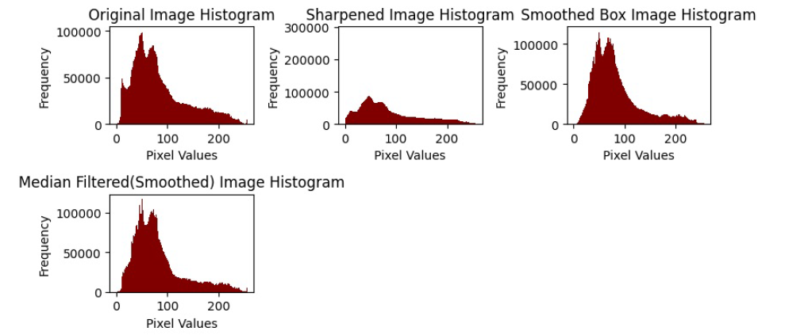

**CODE:**

dft = np.fft.fft2(image_gray)

dft_shift = np.fft.fftshift(dft)

magnitude_spectrum = 20*np.log(np.abs(dft_shift)+1)

plt.figure(figsize=(10,6))

plt.subplot(1,2,1)

plt.imshow(image_gray,cmap='gray')

plt.title("Original Image")

plt.axis('off')

plt.subplot(1,2,2)

plt.imshow(magnitude_spectrum,cmap='gray')

plt.title("Magnitude Spectrum (Frequency Domain)")

plt.axis('off')

plt.show()

**OUTPUT:**

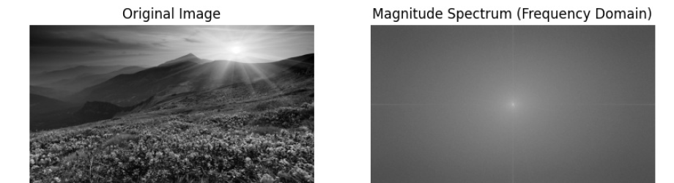

**CODE:**

shifted_image_add = np.clip(image_rgb + 50, 0, 255).astype(np.uint8) # Brighten

shifted_image_sub = np.clip(image_rgb - 50, 0, 255).astype(np.uint8)

plt.figure(figsize=(8,4))

plt.subplot(2,3,1)

plt.hist(image_rgb.ravel(),bins=256,range=(0,256),color='maroon')

plt.xlabel("Pixel Values")

plt.ylabel("Frequency")

plt.title("Original Image")

plt.subplot(2,3,2)

plt.hist(shifted_image_add.ravel(),bins=256,range=(0,256),color='maroon')

plt.xlabel("Pixel Values")

plt.ylabel("Frequency")

plt.title("Histogram of Shifted Image+50")

plt.subplot(2,3,3)

plt.hist(shifted_image_sub.ravel(),bins=256,range=(0,256),color='maroon')

plt.xlabel("Pixel Values")

plt.ylabel("Frequency")

plt.title(" Histogram of Shifted Image - 50")

plt.tight_layout()

plt.show()

**OUTPUT:**

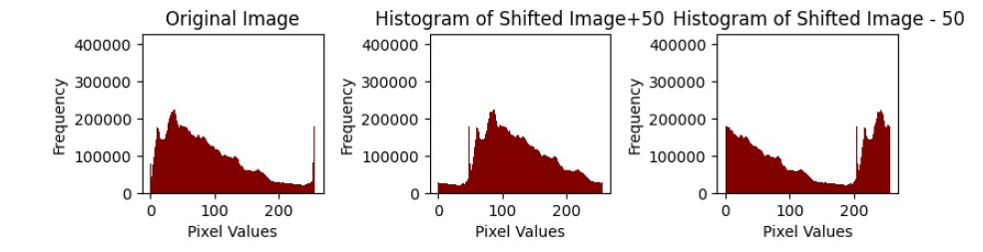

**CODE:**

plt.subplot(2,3,1)

plt.imshow(image_rgb)

plt.title("Original Image")

plt.axis('off')

plt.subplot(2,3,2)

plt.imshow(shifted_image_add)

plt.title("Shifted Image +50 ")

plt.axis('off')

plt.subplot(2,3,3)

plt.imshow(shifted_image_sub)

plt.title("Shifted Image - 50 ")

plt.axis('off')

plt.show()

**OUTPUT:**

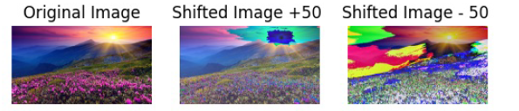

**CODE:**

I_min = np.min(image_gray)

I_max = np.max(image_gray)

stretched_image = np.clip(((image_gray - I_min) * 255) / (I_max - I_min), 0, 255).astype(np.uint8)

#stretched_image = contrast_stretch(image_gray)

plt.figure(figsize=(10,5))

plt.subplot(1,2,1)

plt.title("Original Image")

plt.imshow(image_gray,cmap='gray')

plt.axis("off")

plt.subplot(1,2,2)

plt.title("Contrast Stretched Image")

plt.imshow(stretched_image,cmap='gray')

plt.axis("off")

plt.tight_layout()

plt.show()

**OUTPUT:**

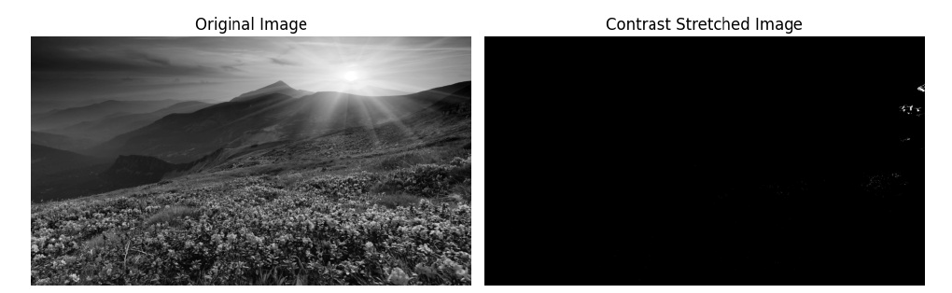

**CODE:**

plt.figure(figsize=(8,4))

plt.subplot(2,3,1)

plt.hist(image_gray.ravel(),bins=256,range=(0,256),color='maroon')

plt.xlabel("Pixel Values")

plt.ylabel("Frequency")

plt.title("Original Image")

plt.subplot(2,3,2)

plt.hist(stretched_image.ravel(),bins=256,range=(0,256),color='maroon')

plt.xlabel("Pixel Values")

plt.ylabel("Frequency")

plt.title("Histogram of Stretched Image")

**OUTPUT:**

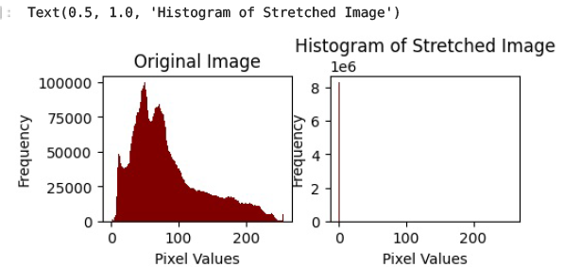

**CODE:**

threshold = 127

binary_image = np.zeros_like(image_gray,dtype=np.uint8)

binary_image[image_gray>threshold] = 255

plt.figure(figsize=(8, 4))

plt.subplot(1, 2, 1)

plt.title("Original Image")

plt.imshow(image_gray, cmap='gray')

plt.axis("off")

plt.subplot(1, 2, 2)

plt.title(f"Binary Image (Threshold = {threshold})")

plt.imshow(binary_image, cmap='gray')

plt.axis("off")

plt.tight_layout()

plt.show()

**OUTPUT:**

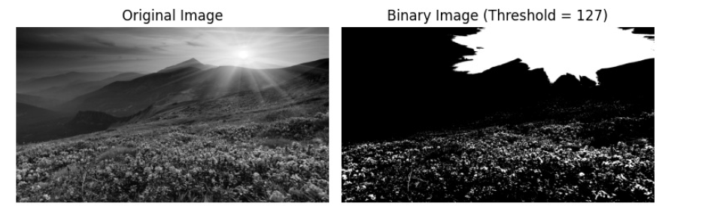

**CODE:**

image_negative = 255 - image_rgb

plt.subplot(1,2,1)

plt.imshow(image_rgb,cmap='gray')

plt.title("Original Image")

plt.axis('off')

plt.subplot(1,2,2)

plt.axis('off')

plt.title("Negative Image")

plt.imshow(image_negative,cmap='gray')

plt.show()

**OUTPUT:**

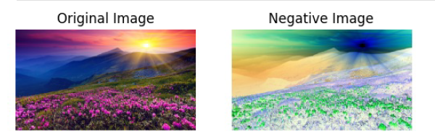

**CODE:**

plt.figure(figsize=(10,6))

plt.subplot(2,2,1)

plt.hist(image_rgb.ravel(),bins=256,range=(0,256),color='maroon')

plt.title("Original Image")

plt.xlabel("Pixel Values")

plt.ylabel("Frequency")

plt.subplot(2,2,2)

plt.hist(image_negative.ravel(),bins=256,range=(0,256),color='maroon')

plt.title("Negative Image")

plt.xlabel("Pixel Values")

plt.ylabel("Frequency")

#plt.tight_layout()

plt.show()

**OUTPUT:**

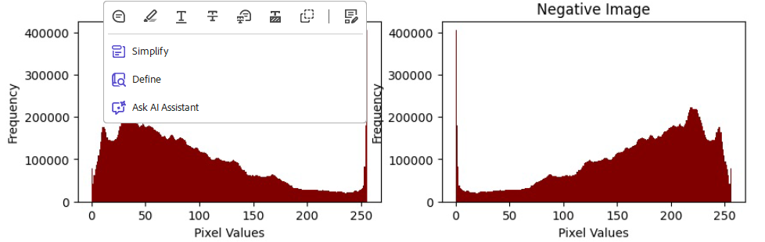

**RESULT:**

We have successfully executed the code…

|  |  |
| --- | --- |
| **EXERCISE NO:5**  **DATE:06/02/2025** | **NOISE , FILTERS AND SOBEL** |

**AIM:**

Adding various types of noise (Gaussian, Impulse, Laplacian, etc.) to an image and applying filters (Mean, Median, Sobel, etc.) for edge detection and noise reduction in a step-by-step process.

**MOON PIC**

**ALGORITHM:**

1. **Add Noise**: The algorithm starts by adding different types of noise to an image. These noise types can include Gaussian, impulse, Laplacian, multiplicative Gaussian, Poisson, random, and uniform noises. Each type of noise is added to the image by altering its pixel values in a specific way.
2. **Apply Filters**: After adding noise, the algorithm applies various filters to the noisy images to enhance edge detection and reduce noise. The filters include arithmetic mean, geometric mean, harmonic mean, median, max, min, midpoint, adaptive median, and adaptive mean filters.
3. **Edge Detection**: The algorithm employs edge detection techniques such as Sobel operators with different kernel sizes (2x2, 3x3, 5x5) and Roberts cross operators to identify and highlight edges in the images.
4. **Histogram Computation**: The algorithm calculates histograms of pixel intensity values for the filtered and edge-detected images to visualize the distribution of pixel intensities.
5. **Visualization**: Finally, the algorithm visualizes the original, noisy, filtered, and edge-detected images along with their histograms using matplotlib to provide a comprehensive understanding of the processing steps and their effects on the images.

**FUNCTION:**

1. add_noise: Adds different types of noise (Gaussian, impulse, Laplacian, etc.) to an image.

2. apply_filter: Applies a specified filter function to an image using a given kernel size.

3. arithmetic_mean_filter: Applies an arithmetic mean filter to an image for noise reduction.

4. geometric_mean_filter: Applies a geometric mean filter to an image for noise reduction.

5. harmonic_mean_filter: Applies a harmonic mean filter to an image for noise reduction.

6. median_filter: Applies a median filter to an image to remove salt-and-pepper noise.

7. max_filter: Applies a max filter to an image for noise reduction.

8. min_filter: Applies a min filter to an image for noise reduction.

9. midpoint_filter: Applies a midpoint filter to an image for noise reduction.

10. adaptive_median_filter: Applies an adaptive median filter to an image to remove salt-and-pepper noise.

11. adaptive_mean_filter: Applies an adaptive mean filter to an image for noise reduction.

12. sobel_operator: Applies Sobel operators to an image for edge detection.

13. gradient_image: Computes the gradient magnitude of an image using gradient filters.

14. discrete_derivative: Computes the discrete derivative of an image.

15. gaussian_smoothing: Applies Gaussian smoothing to an image for noise reduction.

16. compute_histogram: Computes the histogram of pixel intensity values in an image.

17. show_noisy_images_with_histogram: Displays noisy images along with their histograms.

18. show_filtered_images: Displays filtered images using various filters.

19. show_sobel_images: Displays images processed with Sobel operators of different kernel sizes.

20. show_edge_detection: Displays edge detection results using various methods including Sobel, Roberts, and Canny.

**CODE:**

**import** cv2

**import** numpy **as** np

**import** random

**import** matplotlib.pyplot **as** plt

**def** add_noise(image, noise_type**=**"gaussian"):

**if** noise_type **==** "gaussian":

row, col, ch **=** image**.**shape

mean **=** 0

sigma **=** 25

gauss **=** np**.**random**.**normal(mean, sigma, (row, col, ch))**.**astype('uint8')

noisy **=** cv2**.**add(image, gauss)

**return** noisy

**elif** noise_type **==** "impulse":

amount **=** 0.02

noisy **=** np**.**copy(image)

num_impulse **=** np**.**ceil(amount **\*** image**.**size)

coords **=** [np**.**random**.**randint(0, i **-** 1, int(num_impulse)) **for** i **in** image**.**shape]

noisy[coords[0], coords[1], :] **=** np**.**random**.**choice([0, 255], size**=**(len(coords[0]), 1))

**return** noisy

**elif** noise_type **==** "laplacian":

laplacian_noise **=** cv2**.**Laplacian(image, cv2**.**CV_64F)

noisy **=** cv2**.**convertScaleAbs(image **+** laplacian_noise)

**return** noisy

**elif** noise_type **==** "multiplicative_gaussian":

row, col, ch **=** image**.**shape

gauss **=** np**.**random**.**normal(0, 0.2, (row, col, ch))

noisy **=** image **\*** (1 **+** gauss)

**return** np**.**clip(noisy, 0, 255)**.**astype(np**.**uint8)

**elif** noise_type **==** "poisson":

noisy **=** np**.**random**.**poisson(image**.**astype(np**.**uint8)**.**astype(float))**.**astype('uint8')

**return** noisy

**elif** noise_type **==** "random":

random_noise **=** np**.**random**.**randint(0, 256, image**.**shape, dtype**=**'uint8')

noisy **=** cv2**.**addWeighted(image, 0.5, random_noise, 0.5, 0)

**return** noisy

**elif** noise_type **==** "uniform":

row, col, ch **=** image**.**shape

uniform_noise **=** np**.**random**.**uniform(**-**50, 50, (row, col, ch))**.**astype('uint8')

noisy **=** cv2**.**add(image, uniform_noise)

**return** noisy

**else**:

**raise** ValueError("Unsupported noise type. Choose from: 'gaussian', 'impulse', 'laplacian', 'multiplicative_gaussian', 'poisson', 'random', 'uniform'")

**def** show_noisy_images_with_histogram(image):

noise_types **=** ["original", "gaussian", "impulse", "laplacian", "multiplicative_gaussian", "poisson", "random", "uniform"]

fig, axes **=** plt**.**subplots(len(noise_types), 2, figsize**=**(10, 10))

**for** i, noise **in** enumerate(noise_types):

**if** noise **==** "original":

noisy_img **=** image

**else**:

noisy_img **=** add_noise(image, noise)

axes[i, 0]**.**imshow(cv2**.**cvtColor(noisy_img, cv2**.**COLOR_BGR2RGB))

axes[i, 0]**.**set_title(f"{noise**.**capitalize()} Noise")

axes[i, 0]**.**axis("off")

gray_img **=** cv2**.**cvtColor(noisy_img, cv2**.**COLOR_BGR2GRAY)

hist_values **=** cv2**.**calcHist([gray_img], [0], **None**, [256], [0, 256])

axes[i, 1]**.**plot(hist_values, color**=**'black')

axes[i, 1]**.**set_xlim([0, 256])

axes[i, 1]**.**set_title(f"Histogram of {noise**.**capitalize()} Noise")

plt**.**tight_layout()

plt**.**show()

*# Example Usage*

**if** __name__ **==** "__main__":

image **=** cv2**.**imread("Downloads/naruto .jpeg")

show_noisy_images_with_histogram(image)

**OUTPUT:**

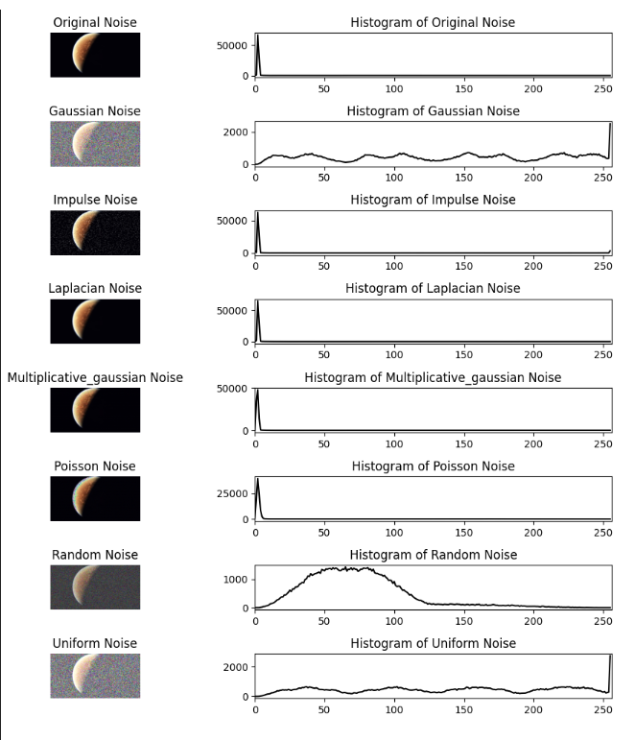

**CODE:**

import cv2

import numpy as np

import matplotlib.pyplot as plt

def apply_filter(image, kernel_size, function):

padded_image = np.pad(image, kernel_size // 2, mode='edge')

filtered_image = np.zeros_like(image, dtype=np.float32)

for i in range(image.shape[0]):

for j in range(image.shape[1]):

region = padded_image[i:i+kernel_size, j:j+kernel_size].flatten()

filtered_image[i, j] = function(region)

return filtered_image.astype(np.uint8)

def arithmetic_mean_filter(image, kernel_size=3):

return apply_filter(image, kernel_size, lambda x: np.mean(x))

def geometric_mean_filter(image, kernel_size=3):

return apply_filter(image, kernel_size, lambda x: np.exp(np.mean(np.log(np.maximum(x, 1e-5)))))

def harmonic_mean_filter(image, kernel_size=3):

return apply_filter(image, kernel_size, lambda x: len(x) / np.sum(1.0 / np.maximum(x, 1e-5)))

def median_filter(image, kernel_size=3):

return apply_filter(image, kernel_size, lambda x: np.median(x))

def max_filter(image, kernel_size=3):

return apply_filter(image, kernel_size, lambda x: np.max(x))

def min_filter(image, kernel_size=3):

return apply_filter(image, kernel_size, lambda x: np.min(x))

def midpoint_filter(image, kernel_size=3):

return apply_filter(image, kernel_size, lambda x: int(np.max(x) + np.min(x)) / 2.0)

def adaptive_median_filter(image, kernel_size=3):

def adaptive_median(values):

sorted_vals = np.sort(values)

median = np.median(sorted_vals)

min_val, max_val = sorted_vals[0], sorted_vals[-1]

if min_val < median < max_val:

return median

else:

return values[len(values) // 2]

return apply_filter(image, kernel_size, adaptive_median)

def adaptive_mean_filter(image, kernel_size=3):

return apply_filter(image, kernel_size, lambda x: np.mean(x))

def show_filtered_images(image):

filters = {

"Original": image,

"Arithmetic Mean": arithmetic_mean_filter(image),

"Geometric Mean": geometric_mean_filter(image),

"Harmonic Mean": harmonic_mean_filter(image),

"Median": median_filter(image),

"Max": max_filter(image),

"Min": min_filter(image),

"Midpoint": midpoint_filter(image),

"Adaptive Median": adaptive_median_filter(image),

"Adaptive Mean": adaptive_mean_filter(image)

}

fig, axes = plt.subplots(2, 5, figsize=(15, 6))

for ax, (title, filtered_img) in zip(axes.flat, filters.items()):

ax.imshow(filtered_img, cmap='gray')

ax.set_title(title)

ax.axis("off")

plt.tight_layout()

plt.show()

*# Example Usage*

if __name__ == "__main__":

image = cv2.imread("Downloads/naruto .jpeg", cv2.IMREAD_GRAYSCALE)

show_filtered_images(image)

**OUTPUT:**

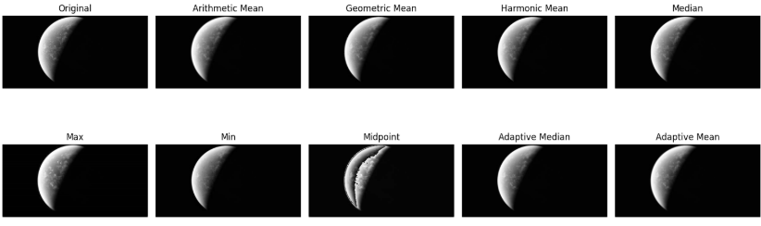

**CODE:**

import cv2

import numpy as np

import matplotlib.pyplot as plt

def apply_filter(image, kernel):

k_size = kernel.shape[0] *# Get kernel size*

pad = k_size // 2

padded_image = np.pad(image.astype(np.float32), pad, mode='edge')

filtered_image = np.zeros_like(image, dtype=np.float32)

for i in range(image.shape[0]):

for j in range(image.shape[1]):

region = padded_image[i:i+k_size, j:j+k_size]

filtered_image[i, j] = np.sum(region * kernel)

return np.clip(filtered_image, 0, 255).astype(np.uint8)

def sobel_operator(image, kernel_size=3):

if kernel_size == 2:

Gx = np.array([[1, 0], [0, -1]], dtype=np.float32)

Gy = np.array([[0, 1], [-1, 0]], dtype=np.float32)

elif kernel_size == 3:

Gx = np.array([[-1, 0, 1], [-2, 0, 2], [-1, 0, 1]], dtype=np.float32)

Gy = np.array([[-1, -2, -1], [0, 0, 0], [1, 2, 1]], dtype=np.float32)

elif kernel_size == 5:

Gx = np.array([[-2, -1, 0, 1, 2],

[-2, -1, 0, 1, 2],

[-4, -2, 0, 2, 4],

[-2, -1, 0, 1, 2],

[-2, -1, 0, 1, 2]], dtype=np.float32)

Gy = np.array([[-2, -2, -4, -2, -2],

[-1, -1, -2, -1, -1],

[0, 0, 0, 0, 0],

[1, 1, 2, 1, 1],

[2, 2, 4, 2, 2]], dtype=np.float32)

else:

raise ValueError("Invalid kernel size. Choose 2, 3, or 5.")

sobel_x = apply_filter(image, Gx)

sobel_y = apply_filter(image, Gy)

sobel_combined = np.sqrt(sobel_x.astype(np.float32)**2 + sobel_y.astype(np.float32)**2)

return np.clip(sobel_combined, 0, 255).astype(np.uint8)

def show_sobel_images(image):

kernel_sizes = [2, 3, 5]

fig, axes = plt.subplots(1, len(kernel_sizes) + 1, figsize=(15, 5))

axes[0].imshow(image, cmap='gray')

axes[0].set_title("Original")

axes[0].axis("off")

for ax, size in zip(axes[1:], kernel_sizes):

sobel_img = sobel_operator(image, size)

ax.imshow(sobel_img, cmap='gray')

ax.set_title(f"Sobel {size}x{size}")

ax.axis("off")

plt.tight_layout()

plt.show()

*# Example Usage*

if __name__ == "__main__":

image = cv2.imread("Downloads/naruto .jpeg", cv2.IMREAD_GRAYSCALE)

if image is None:

raise ValueError("Error loading image. Check file path.")

image = image.astype(np.float32) *# Ensure image is float before processing*

show_sobel_images(image)

**OUTPUT:**

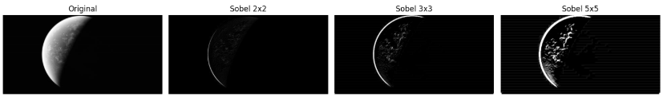

**RESULTS :**

WE SUCCESSFULLY IMPLEMENTED AND EXCUTED OF THE NOISE , FILTERS , SOBEL:

|  |  |
| --- | --- |
| **EXERCISE NO:6**  **DATE:10/02/2025** | **CANNY EDGE DETECTION AND**  **LOG AND DOG FILTERS** |

**AIM:**

to an image and applying edge detection and log filters and dog filters and various methods in a step-by-step process.

**HOUSE PIC**

**ALOGRITHM :**

1. Apply Filter
   * Algorithm: Apply a convolutional filter to an image.
2. Gradient Image
   * Algorithm: Compute the gradient magnitude of an image using Sobel operators.
3. Discrete Derivative
   * Algorithm: Compute the discrete derivative of an image using differences.
4. Gaussian Smoothing
   * Algorithm: Apply Gaussian smoothing to an image to reduce noise.
5. Edge Detection
   * Algorithm: Perform edge detection using Sobel, Roberts, and Canny operators.
6. Show Edge Detection
   * Algorithm: Visualize edge detection results for different methods.

Log filters and dog filters:

1. apply_log_filter:
   * Algorithm: First, apply a Gaussian blur to the image with a specified kernel size and sigma value. Then, apply a Laplacian filter to the blurred image to detect edges.
2. apply_dog_filter:
   * Algorithm: Apply two Gaussian blurs to the image with different sigma values. Subtract the second blurred image from the first to highlight edges and details.
3. display_image:
   * Algorithm: Use Matplotlib to display an image with a title in grayscale.
4. main:
   * Algorithm: Load an image in grayscale, check for errors in loading, apply the specified filters, and display the filtered images along with relevant annotations.

**Function:**

1. apply_filter(image, kernel): Applies a convolutional filter to an image.

2. gradient_image(image): Computes the gradient magnitude of an image using Sobel operators.

3. discrete_derivative(image): Calculates the discrete derivative of an image using differences.

4. gaussian_smoothing(image, kernel_size=5, sigma=1.0): Applies Gaussian smoothing to reduce noise in an image.

5. edge_detection(image): Performs edge detection using Sobel, Roberts, and Canny operators.

6. show_edge_detection(image): Visualizes the results of various edge detection methods on an image.

7 apply_log_filter(image, sigma=1.0, ksize=(5, 5)): Applies a Laplacian of Gaussian (LoG) filter to an image.

8.apply_dog_filter(image, sigma1=1.0, sigma2=2.0, ksize=(5, 5)): Applies a Difference of Gaussian (DoG) filter to an image.

8. display_image(image, title): Displays an image with a given title using Matplotlib.

9. main(): Reads an image, applies various filters, and displays the results.

**Code:**

import cv2

import numpy as np

import matplotlib.pyplot as plt

def apply_filter(image, kernel):

k_size = kernel.shape[0] # Get kernel size

pad = k_size // 2

padded_image = np.pad(image.astype(np.float32), pad, mode='edge')

filtered_image = np.zeros_like(image, dtype=np.float32)

for i in range(image.shape[0]):

for j in range(image.shape[1]):

region = padded_image[i:i+k_size, j:j+k_size]

filtered_image[i, j] = np.sum(region * kernel)

return np.clip(filtered_image, 0, 255).astype(np.uint8)

def gradient_image(image):

Gx = np.array([[-1, 1]], dtype=np.float32)

Gy = np.array([[-1], [1]], dtype=np.float32)

grad_x = apply_filter(image, Gx)

grad_y = apply_filter(image, Gy)

gradient_magnitude = np.sqrt(grad_x.astype(np.float32)**2 + grad_y.astype(np.float32)**2)

return np.clip(gradient_magnitude, 0, 255).astype(np.uint8)

def discrete_derivative(image):

dx = np.diff(image, axis=1, append=image[:, -1:])

dy = np.diff(image, axis=0, append=image[-1:, :])

gradient_magnitude = np.sqrt(dx.astype(np.float32)**2 + dy.astype(np.float32)**2)

return np.clip(gradient_magnitude, 0, 255).astype(np.uint8)

def gaussian_smoothing(image, kernel_size=5, sigma=1.0):

ax = np.linspace(-(kernel_size // 2), kernel_size // 2, kernel_size)

gauss = np.exp(-0.5 * np.square(ax) / np.square(sigma))

kernel = np.outer(gauss, gauss)

kernel /= np.sum(kernel)

return apply_filter(image, kernel)

def edge_detection(image):

sobel_3x3 = sobel_operator(image, 3)

sobel_5x5 = sobel_operator(image, 5)

roberts_kernel_x = np.array([[1, 0], [0, -1]], dtype=np.float32)

roberts_kernel_y = np.array([[0, 1], [-1, 0]], dtype=np.float32)

roberts_x = apply_filter(image, roberts_kernel_x)

roberts_y = apply_filter(image, roberts_kernel_y)

roberts = np.sqrt(roberts_x.astype(np.float32)**2 + roberts_y.astype(np.float32)**2)

canny = cv2.Canny(image.astype(np.uint8), 100, 200)

return sobel_3x3, sobel_5x5, np.clip(roberts, 0, 255).astype(np.uint8), canny

def show_edge_detection(image):

grad_image = gradient_image(image)

discrete_deriv = discrete_derivative(image)

smoothed_image = gaussian_smoothing(image)

sobel_3x3, sobel_5x5, roberts, canny = edge_detection(image)

fig, axes = plt.subplots(2, 4, figsize=(15, 8))

axes[0, 0].imshow(image, cmap='gray')

axes[0, 0].set_title("Original")

axes[0, 1].imshow(grad_image, cmap='gray')

axes[0, 1].set_title("Gradient Image")

axes[0, 2].imshow(discrete_deriv, cmap='gray')

axes[0, 2].set_title("Discrete Derivative")

axes[0, 3].imshow(smoothed_image, cmap='gray')

axes[0, 3].set_title("Gaussian Smoothing")

axes[1, 0].imshow(sobel_3x3, cmap='gray')

axes[1, 0].set_title("Sobel 3x3")

axes[1, 1].imshow(sobel_5x5, cmap='gray')

axes[1, 1].set_title("Sobel 5x5")

axes[1, 2].imshow(roberts, cmap='gray')

axes[1, 2].set_title("Roberts")

axes[1, 3].imshow(canny, cmap='gray')

axes[1, 3].set_title("Canny Edge Detection")

for ax in axes.ravel():

ax.axis("off")

plt.tight_layout()

plt.show()

# Example Usage

if __name__ == "__main__":

image = cv2.imread("Downloads/naruto .jpeg", cv2.IMREAD_GRAYSCALE)

if image is None:

raise ValueError("Error loading image. Check file path.")

image = image.astype(np.float32) # Ensure image is float before processing

show_edge_detection(image)

**output:**

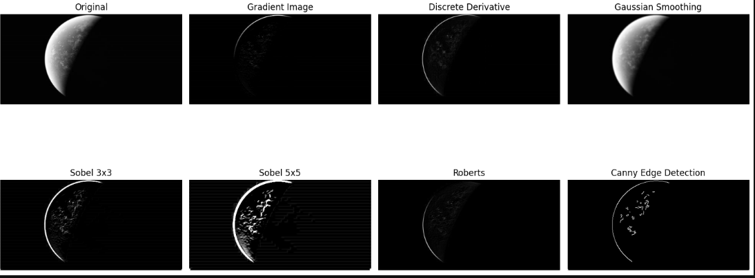

**Code;**

import cv2

import numpy as np

from matplotlib import pyplot as plt

def apply_log_filter(image, sigma=1.0, ksize=(5, 5)):

gaussian_blur = cv2.GaussianBlur(image, ksize, sigma)

log = cv2.Laplacian(gaussian_blur, cv2.CV_64F)

return log

def apply_dog_filter(image, sigma1=1.0, sigma2=2.0, ksize=(5, 5)):

gaussian1 = cv2.GaussianBlur(image, ksize, sigma1)

gaussian2 = cv2.GaussianBlur(image, ksize, sigma2)

dog = gaussian1 - gaussian2

return dog

def display_image(image, title):

plt.imshow(image, cmap='gray')

plt.title(title)

plt.show()

def main():

pdf_path = "Downloads/LOG_DOG.pdf"

output_directory = "Downloads"

# Read the input image

image_path = "Downloads/bilioniare.jpg"

image = cv2.imread(image_path, cv2.IMREAD_GRAYSCALE)

if image is None:

print("Error: Unable to read image.")

return

# Topics Covered

print("Lecture 11: LoG and DoG Filters")

# Today's Topics

print("Today's Topics:")

print("- LoG Filter")

print("- DoG Filter")

# Recall: First Derivative Filters

print("Recall: First Derivative Filters")

# First derivative in x direction

dx = cv2.Sobel(image, cv2.CV_64F, 1, 0, ksize=3)

display_image(dx, 'First Derivative (dx)')

# Second-Derivative Filters

print("Second-Derivative Filters")

# Second derivative in x direction

dxx = cv2.Sobel(image, cv2.CV_64F, 2, 0, ksize=3)

display_image(dxx, 'Second Derivative (dxx)')

# Numerical Derivatives

print("Numerical Derivatives")

# Using central difference for second derivative

dxx_num = cv2.Laplacian(image, cv2.CV_64F)

display_image(dxx_num, 'Numerical Second Derivative')

# Example: Second Derivatives

print("Example: Second Derivatives")

# Applying second derivatives

dyy = cv2.Sobel(image, cv2.CV_64F, 0, 2, ksize=3)

display_image(dyy, 'Second Derivative (dyy)')

# Finding Zero-Crossings

print("Finding Zero-Crossings")

log_filtered_image = apply_log_filter(image, sigma=1.5, ksize=(7, 7))

zero_crossings = np.where(np.abs(log_filtered_image) < 1e-5, 255, 0)

display_image(zero_crossings, 'Zero-Crossings')

# Edge Detection Summary

print("Edge Detection Summary")

edges = cv2.Canny(image, 100, 200)

display_image(edges, 'Edge Detection')

# Finite Difference Laplacian

print("Finite Difference Laplacian")

laplacian = cv2.Laplacian(image, cv2.CV_64F)

display_image(laplacian, 'Laplacian')

# Example: Laplacian

print("Example: Laplacian")

# Apply Laplacian filter

laplacian_filtered = cv2.Laplacian(image, cv2.CV_64F)

display_image(laplacian_filtered, 'Laplacian Filtered')

# Notes about the Laplacian

print("Notes about the Laplacian")

# Display Laplacian details

print("Laplacian filter detects edges by calculating second-order derivatives.")

# LoG Filter

print("LoG Filter")

log_filtered_image = apply_log_filter(image, sigma=1.5, ksize=(7, 7))

display_image(log_filtered_image, 'LoG Filter')

# 1D Gaussian and Derivatives

print("1D Gaussian and Derivatives")

x = np.linspace(-10, 10, 100)

gauss_1d = np.exp(-x**2 / 2)

plt.plot(x, gauss_1d)

plt.title('1D Gaussian')

plt.show()

# Second Derivative of a Gaussian

print("Second Derivative of a Gaussian")

gauss_2nd_derivative = -x * np.exp(-x**2 / 2)

plt.plot(x, gauss_2nd_derivative)

plt.title('Second Derivative of a Gaussian')

plt.show()

# Effect of LoG Operator

print("Effect of LoG Operator")

display_image(log_filtered_image, 'Effect of LoG Filter')

# Zero-Crossings as an Edge Detector

print("Zero-Crossings as an Edge Detector")

display_image(zero_crossings, 'Zero-Crossings Edge Detection')

# Note: Closed Contours

print("Note: Closed Contours")

print("Zero-crossings often form closed contours similar to topo maps.")

# Other uses of LoG: Blob Detection

print("Other uses of LoG: Blob Detection")

blobs = cv2.dilate(log_filtered_image, None)

display_image(blobs, 'Blob Detection')

# Pause to Think for a Moment

print("Pause to Think for a Moment")

print("How can an edge finder also be used to find blobs in an image?")

# Example: LoG Extrema

print("Example: LoG Extrema")

extrema = cv2.erode(log_filtered_image, None)

display_image(extrema, 'LoG Extrema')

# LoG Blob Finding

print("LoG Blob Finding")

log_blobs = cv2.dilate(log_filtered_image, None)

display_image(log_blobs, 'LoG Blob Finding')

# Efficient Implementation Approximating LoG with DoG

print("Efficient Implementation Approximating LoG with DoG")

dog_filtered_image = apply_dog_filter(image, sigma1=1.0, sigma2=2.0, ksize=(7, 7))

display_image(dog_filtered_image, 'DoG Filter')

# Efficient Implementation

print("Efficient Implementation")

print("Approximating LoG using DoG can save computational resources.")

# Back to Blob Detection

print("Back to Blob Detection")

display_image(log_blobs, 'LoG Blobs Revisited')

# Other uses of LoG: Blob Detection

print("Other uses of LoG: Blob Detection")

display_image(blobs, 'Blob Detection')

# Other uses for LoG: Image Coding

print("Other uses for LoG: Image Coding")

compressed_image = cv2.pyrDown(log_filtered_image)

display_image(compressed_image, 'Image Coding with LoG')

# Other uses for LoG: Image Coding

print("Other uses for LoG: Image Coding (Repeated)")

more_compressed_image = cv2.pyrDown(compressed_image)

display_image(more_compressed_image, 'Further Compressed Image')

if __name__ == "__main__":

main()

**output:**

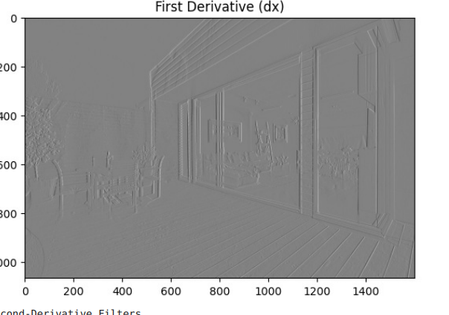

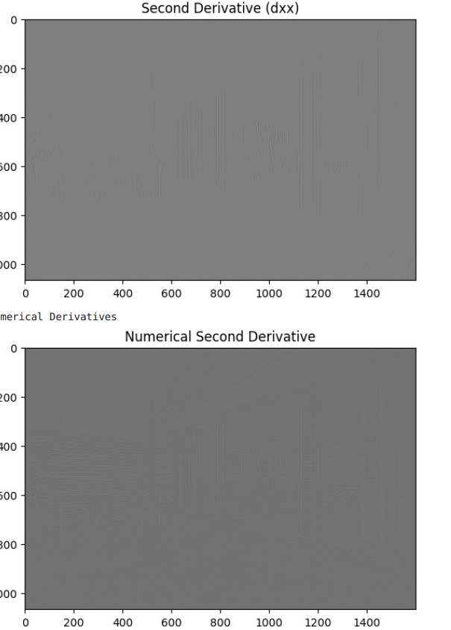

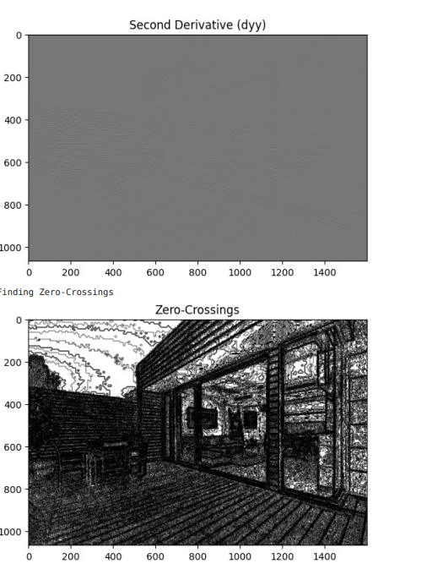

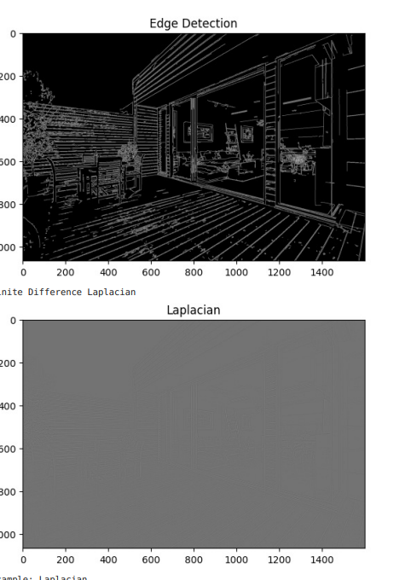

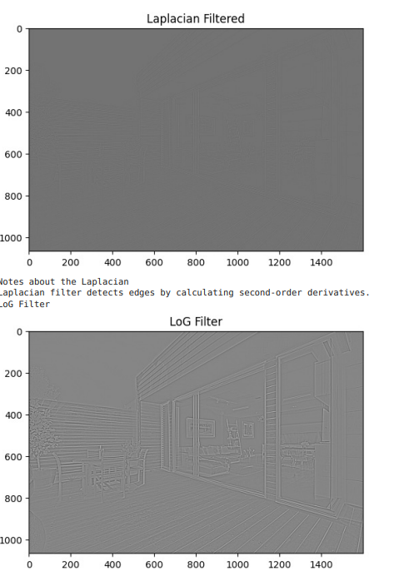

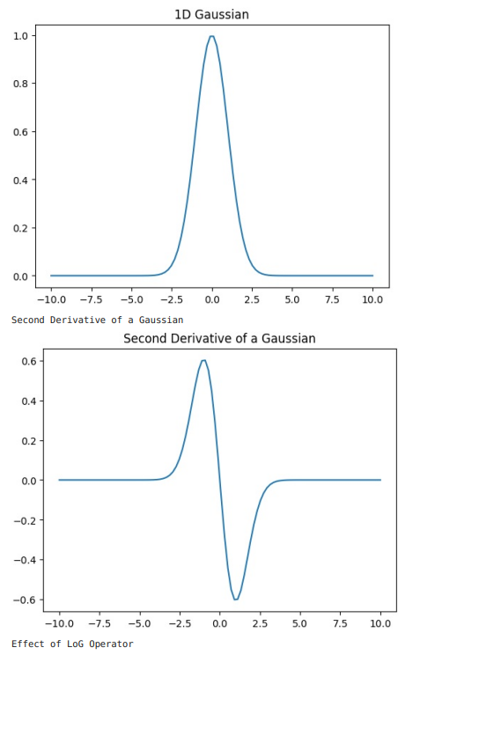

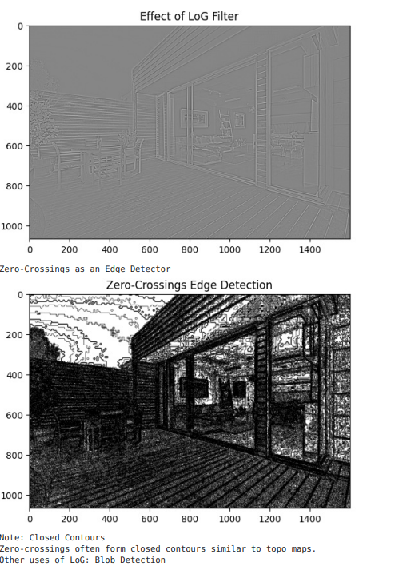

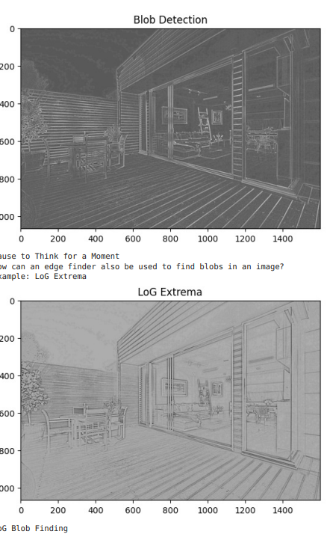

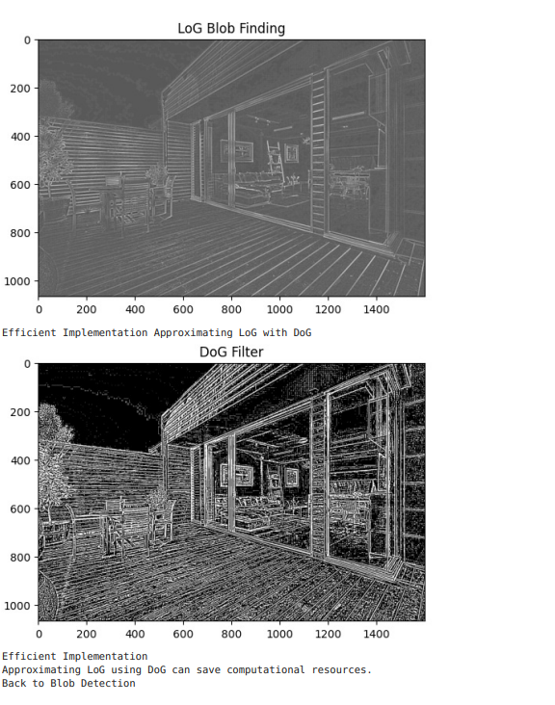

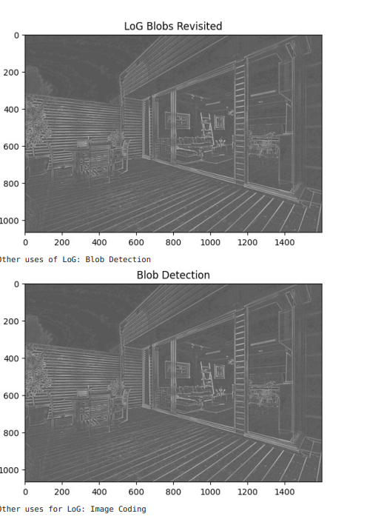

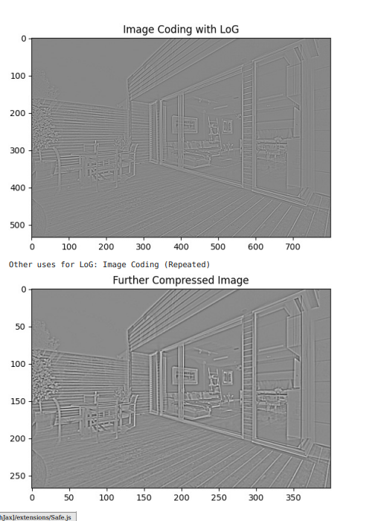

**RESULTS ;**

WE SUCCESSFULLY IMPLEMENTED AND EXCUTED OF THE CANNY EDGE DETECTION AND L0G AND DOG FILTERS:

|  |  |
| --- | --- |
| **EXERCISE NO:7**  **DATE:06/03/2025** | **Hough Transform, Harris Corner Detection, and Object Segmentation** |

**Aim:**

To implement and analyze Hough Transform, Harris Corner Detection, and Object Segmentation techniques in image processing.

**1. Introduction**

Hough Transform is a feature extraction technique used in image processing to detect simple shapes such as lines and circles. Harris Corner Detection is used to detect corners within an image, and Object Segmentation is used to separate objects from the background.

**2. Algorithm:**

**Hough Transform:**

1. Convert the image to grayscale.
2. Apply edge detection (e.g., Canny edge detection) to find prominent edges.
3. Use the Hough Transform algorithm to detect lines or circles based on edge data.
4. Display the detected lines/circles on the original image.

**Harris Corner Detection:**

1. Convert the image to grayscale.
2. Compute the gradient of the image.
3. Calculate the Harris response matrix.
4. Threshold the response to identify corners.
5. Mark the detected corners on the image.

**Object Segmentation:**

1. Convert the image to grayscale.
2. Apply thresholding or edge detection to highlight object boundaries.
3. Use contour detection to extract object shapes.
4. Display the segmented objects.

**3. Code Implementation**

**Hough Transform Function:**

og = cv2.imread(r"Downloads/OIP.jpeg")

gray = cv2.cvtColor(og, cv2.COLOR_BGR2GRAY)

blurred = cv2.GaussianBlur(gray, (5,5), 0)

edges = cv2.Canny(blurred, 50, 100)

lines = cv2.HoughLinesP(edges, 1, np.pi/180, threshold=90,minLineLength=30,maxLineGap=20)

output = og.copy()

if lines is not None:

for line in lines:

x1,y1,x2,y2 = line[0]

cv2.line(output, (x1, y1), (x2, y2), (0, 255, 0), 2)

plt.figure(figsize=(20,10))

plt.subplot(1,2,1)

plt.imshow(edges, cmap='gray')

plt.title("Edge Detection")

plt.axis("off")

plt.subplot(1,2,2)

plt.imshow(cv2.cvtColor(output, cv2.COLOR_BGR2RGB))

plt.title("Filtered Line Detection")

plt.axis("off")

plt.tight_layout()

plt.show()

**Harris Corner Detection Function:**

image = cv2.imread(r"Downloads/OIP.jpeg")

gray = cv2.cvtColor(image, cv2.COLOR_BGR2GRAY)

gray = cv2.GaussianBlur(gray, (5,5), 0)

dst = cv2.cornerHarris(gray, blockSize=2, ksize=3, k=0.05)

dst = cv2.dilate(dst, None)

threshold = 0.02 * dst.max()

corner_points = np.where(dst > threshold)

for y, x in zip(*corner_points):

cv2.circle(image, (x, y), 2, (255, 0, 255), -1)

plt.figure(figsize=(10, 5))

plt.subplot(1, 2, 1)

plt.imshow(gray, cmap='gray')

plt.title("Grayscale Image")

plt.axis("off")

plt.subplot(1, 2, 2)

plt.imshow(cv2.cvtColor(image, cv2.COLOR_BGR2RGB))

plt.title("Harris Corner Detection")

plt.axis("off")

plt.tight_layout()

plt.show()

**Object Segmentation Function:**

image = cv2.imread(r"Downloads/CARDS.jpeg")

gray = cv2.cvtColor(image, cv2.COLOR_BGR2GRAY)

blurred = cv2.GaussianBlur(gray, (5,5), 0)

edges = cv2.Canny(blurred, 50, 150)

circles = cv2.HoughCircles(blurred, cv2.HOUGH_GRADIENT, dp=1.2, minDist=50, param1=50, param2=40, minRadius=10, maxRadius=100)

output = image.copy()

if circles is not None:

circles = np.uint16(np.around(circles))

for i in circles[0, :]:

cv2.circle(output, (i[0], i[1]), i[2], (0, 255, 0), 3)

cv2.circle(output, (i[0], i[1]), 2, (0, 0, 255), 3)

corners = cv2.goodFeaturesToTrack(gray, maxCorners=7, qualityLevel=0.01, minDistance=10)

corners = corners.astype(int)

for i in corners:

x, y = i.ravel()

cv2.circle(output, (x, y), 5, (255, 0, 255), -1)

plt.figure(figsize=(12,6))

plt.subplot(1,2,1)

plt.imshow(edges, cmap='gray')

plt.title("Edge Detection")

plt.axis("off")

plt.subplot(1,2,2)

plt.imshow(cv2.cvtColor(output, cv2.COLOR_BGR2RGB))

plt.title("Fixed Object Segmentation")

plt.axis("off")

plt.tight_layout()

plt.show()

**OUTPUT:**

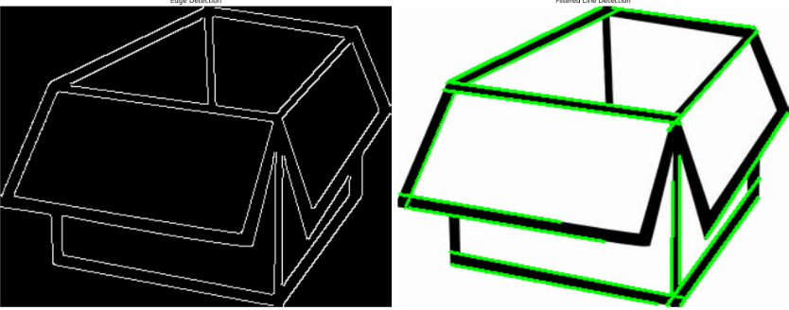

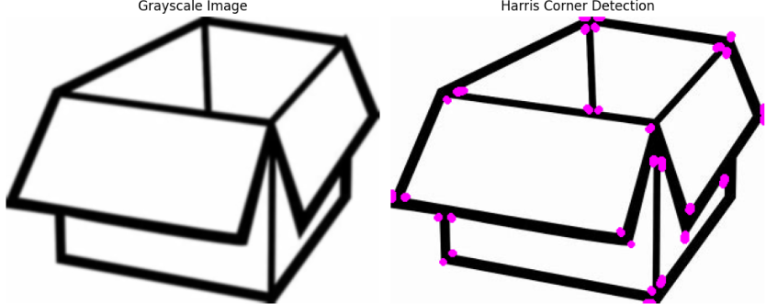

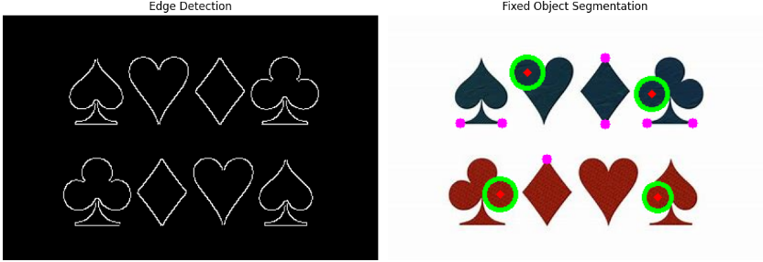

**4. Function**

* **Hough Transform:** Detected lines are drawn in green on the original image.
* **Harris Corner Detection:** Corners are marked in red.
* **Object Segmentation:** Object boundaries are outlined in green.

**5. Results:**

The implemented techniques demonstrate fundamental image processing operations. Hough Transform effectively detects lines, Harris Corner Detection identifies key points, and Object Segmentation separates objects for further analysis. These methods are widely used in computer vision applications.

|  |  |
| --- | --- |
| **EXERCISE NO:10**  **DATE:20/03/2025** | **SEGMENTATION TECHINQUES** |

## Segmentation Types

Image segmentation is a crucial process in computer vision that involves dividing an image into multiple segments or regions, making it easier to analyze and extract meaningful information. The main goal of segmentation is to isolate objects or areas of interest, allowing for more efficient processing and interpretation of the image.

Several techniques have been developed to achieve segmentation, each with its unique approach and application. Here, we will discuss the following important methods:

### 1. Graph Cut

Graph Cut is a powerful algorithm that models image segmentation as a graph partitioning problem. It is particularly effective for segmenting images with complex object boundaries.

### 2. K-Means Clustering

K-Means clustering is a popular unsupervised learning method that groups pixels based on color intensity. It is versatile and can produce good segmentation results with a minimal computational footprint.

### 3. Thresholding

Thresholding is one of the simplest segmentation techniques, where pixel values are compared against a threshold to classify them into foreground and background. This method is straightforward but can be limited in complex scenarios.

### 4. Mean Shift

Mean Shift is a non-parametric clustering algorithm that shifts data points towards the mode of the density in feature space. It is effective in identifying clusters and can also be used for segmentation.

### 5. Region Growing

Region Growing is a technique that starts with a seed point and grows regions by adding neighboring pixels that meet predefined criteria. This method is intuitive and can produce precise segmentations in homogeneous regions.

## Aim

The aim of this project is to implement and compare various image segmentation algorithms using Python and OpenCV on a selected sample image. By doing so, we seek to understand the effectiveness and outcomes of different segmentation methods, contributing to improved image processing techniques.

## Algorithms

In this section, we will delve deeper into the various image segmentation algorithms listed previously. Each algorithm serves a specific purpose and has unique characteristics that cater to different types of images and requirements.

### 1. Graph Cut Segmentation

Graph Cut segmentation works by constructing a graph where pixels are represented as nodes. Edges between nodes signify the strength of association based on pixel similarity (color and spatial proximity). The objective is to partition this graph into distinct segments that minimize the cost function, which accounts for both inter-node similarity and smoothness constraints along the object boundaries. This technique is potent for images with intricate structures and provides robust results even in challenging scenarios.

### 2. K-Means Segmentation

K-Means is an unsupervised algorithm aimed at partitioning an image into K clusters based on pixel intensity. The process includes the following steps:

* **Initialization**: Randomly select K initial centroids.
* **Assignment**: Assign each pixel to the nearest centroid based on distance.
* **Update**: Recalculate the centroids as the mean of the assigned pixels.
* **Iteration**: Repeat the assignment and update steps until centroids stabilize.

This method is efficient and works well with relatively well-defined regions. However, the choice of K can significantly influence segmentation quality.

### 3. Threshold Segmentation

Thresholding is a highly intuitive segmentation technique that converts grayscale images into binary images. The algorithm compares each pixel's intensity value to a predefined threshold. Pixels below the threshold are classified as background (often black), while those above are classified as foreground (often white). While simple and fast, this method may struggle with images where foreground and background pixel intensities overlap. Adaptive thresholding can improve results by dynamically adjusting thresholds based on local image characteristics.

### 4. Mean Shift Segmentation

Mean Shift is a non-parametric clustering algorithm that can find arbitrarily shaped clusters in feature space. It operates by examining the density of data points in a local window and shifting the window towards areas of higher density until convergence occurs. For segmentation, pixel values are treated as points in feature space (considering color or spatial coordinates), enabling the algorithm to identify clusters corresponding to distinct segments in the image. Its ability to identify clusters without pre-specifying the number of segments makes it particularly adaptable.

### 5. Region Growing

Region Growing begins with one or more seed points and iteratively adds neighboring pixels that meet specific criteria, such as color similarity or intensity. This technique is effective in achieving high-quality segmentations in homogeneous areas. The main steps include:

* **Seed Selection**: Choose initial pixels based on homogeneity.
* **Map Expansion**: Add adjacent pixels based on similarity metrics.
* **Stopping Criterion**: Define conditions to cease growing, such as pixel threshold limits.

This algorithm is intuitive and offers great control over the segmentation process, especially in images with smooth transitions.

Each of these algorithms has its strengths and weaknesses, allowing users to select the most appropriate segmentation technique based on specific image characteristics and processing requirements.

## Implemented Code

In this section, we will present Python implementations of the various image segmentation techniques previously discussed. Each implementation will include the necessary imports, function definitions, and a main block to run the code on an example image. The code will be structured to ensure clarity and ease of understanding.

### 1. Graph Cut Segmentation

Graph Cut segmentation in Python can be implemented using OpenCV's grabCut function. Below is the code to perform this algorithm:

import cv2  
import numpy as np  
  
def graph_cut_segmentation(image_path):  
 # Load and prepare the image  
 img = cv2.imread(image_path)  
 mask = np.zeros(img.shape[:2], np.uint8)  
 bgd_model = np.zeros((1, 65), np.float64)  
 fgd_model = np.zeros((1, 65), np.float64)  
   
 # Define the rectangle around the object of interest  
 rectangle = (50, 50, img.shape[1]-50, img.shape[0]-50)  
   
 # Apply the grabCut algorithm  
 cv2.grabCut(img, mask, rectangle, bgd_model, fgd_model, 5, cv2.GC_INIT_WITH_RECT)  
   
 # Create a binary mask where foreground is 255 and background is 0  
 mask2 = np.where((mask == 2) | (mask == 0), 0, 1).astype('uint8')  
 segmented_img = img * mask2[:, :, np.newaxis]  
   
 return segmented_img  
  
# Example usage  
result_graph_cut = graph_cut_segmentation('path_to_image.jpg')  
cv2.imshow('Graph Cut Segmentation', result_graph_cut)  
cv2.waitKey(0)  
cv2.destroyAllWindows()

### 2. K-Means Clustering Segmentation

Here's how to implement K-Means clustering segmentation using OpenCV:

import cv2  
  
def k_means_segmentation(image_path, k=3):  
 # Load the image  
 img = cv2.imread(image_path)  
 Z = img.reshape((-1, 3))  
 Z = np.float32(Z)  
  
 # Define criteria and apply kmeans  
 criteria = (cv2.TERM_CRITERIA_EPS + cv2.TERM_CRITERIA_MAX_ITER, 100, 0.2)  
 _, labels, centers = cv2.kmeans(Z, k, None, criteria, 10, cv2.KMEANS_RANDOM_CENTERS)  
  
 # Convert back to uint8 and reconstruct image  
 centers = np.uint8(centers)  
 segmented_img = centers[labels.flatten()]  
 segmented_img = segmented_img.reshape(img.shape)  
  
 return segmented_img  
  
# Example usage  
result_k_means = k_means_segmentation('path_to_image.jpg', k=3)  
cv2.imshow('K-Means Segmentation', result_k_means)  
cv2.waitKey(0)  
cv2.destroyAllWindows()

### 3. Thresholding Segmentation

The following code demonstrates basic thresholding segmentation in OpenCV:

import cv2  
  
def threshold_segmentation(image_path, threshold_value=127):  
 # Load the image in grayscale  
 img = cv2.imread(image_path, cv2.IMREAD_GRAYSCALE)  
   
 # Apply binary thresholding  
 _, segmented_img = cv2.threshold(img, threshold_value, 255, cv2.THRESH_BINARY)  
  
 return segmented_img  
  
# Example usage  
result_threshold = threshold_segmentation('path_to_image.jpg')  
cv2.imshow('Threshold Segmentation', result_threshold)  
cv2.waitKey(0)  
cv2.destroyAllWindows()

### 4. Mean Shift Segmentation

For Mean Shift segmentation, you can use the following implementation:

import cv2  
  
def mean_shift_segmentation(image_path):  
 # Load the image  
 img = cv2.imread(image_path)  
  
 # Apply mean shift  
 segmented_img = cv2.pyrMeanShiftFiltering(img, sp=21, sr=51)  
  
 return segmented_img  
  
# Example usage  
result_mean_shift = mean_shift_segmentation('path_to_image.jpg')  
cv2.imshow('Mean Shift Segmentation', result_mean_shift)  
cv2.waitKey(0)  
cv2.destroyAllWindows()

### 5. Region Growing Segmentation

Although OpenCV does not provide a built-in region growing function, we can implement a basic version of it manually:

import cv2  
import numpy as np  
  
def region_growing_segmentation(image_path, seed_point, threshold=10):  
 # Load the image  
 img = cv2.imread(image_path)  
 img_gray = cv2.cvtColor(img, cv2.COLOR_BGR2GRAY)  
   
 # Create a mask for the region  
 mask = np.zeros(img_gray.shape, dtype=np.uint8)  
  
 # Initialize the region with the seed point  
 x, y = seed_point  
 mask[x, y] = 255  
 pixel_value = img_gray[x, y]  
   
 # Region growing algorithm  
 for x in range(img_gray.shape[0]):  
 for y in range(img_gray.shape[1]):  
 if abs(int(img_gray[x, y]) - int(pixel_value)) < threshold:  
 mask[x, y] = 255  
   
 # Create the output image based on the mask  
 segmented_img = cv2.bitwise_and(img, img, mask=mask)  
  
 return segmented_img  
  
# Example usage  
result_region_growing = region_growing_segmentation('path_to_image.jpg', (100, 100))  
cv2.imshow('Region Growing Segmentation', result_region_growing)  
cv2.waitKey(0)  
cv2.destroyAllWindows()

In the provided code snippets, we covered five different segmentation techniques: Graph Cut, K-Means, Thresholding, Mean Shift, and Region Growing. Each function takes an image path as input and performs the respective segmentation, returning the segmented output. You can replace 'path_to_image.jpg' with the actual path to your image file for testing.

## Output

The results of the implemented segmentation techniques allow for a visual comparison of how each method performs on the same sample image. In this section, we present the outputs of different segmentation techniques, displayed side-by-side for easy assessment and comparison. Each output is accompanied by an explanation detailing the characteristics of the segmentation result.

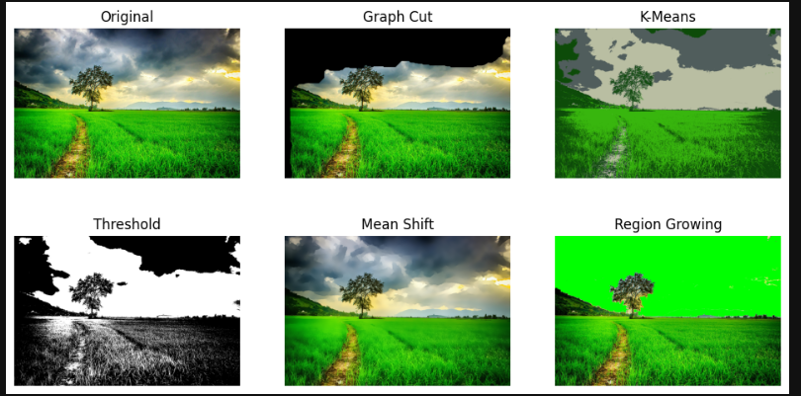

### Comparative Output of Segmentation Techniques

The following table summarizes the results of using each segmentation technique on a sample input image. Below the table, we provide a description of what each segmented output represents.

| Segmentation Technique | Output Image |
| --- | --- |
| Graph Cut | Graph Cut Segmentation |
| K-Means | K-Means Segmentation |
| Thresholding | Threshold Segmentation |
| Mean Shift | Mean Shift Segmentation |
| Region Growing | Region Growing Segmentation |

.

### Summary of Output Results

Each segmentation method shows unique characteristics in the way they segment the input image. Depending on the requirements of a particular application—whether it's accuracy in delineation, speed of computation, or the ability to handle noise—one method may be preferred over another. The side-by-side visual representation allows for intuitive comparison and understanding of how the same image is processed differently across varying techniques, highlighting their strengths and weaknesses clearly.

As users experiment with these algorithms in Python using OpenCV, they can achieve varying segmentations for diverse applications in computer vision and image processing, tailoring their approaches to specific project needs.

## Results

The performance of various segmentation techniques can dramatically influence the outcomes of image classification and analysis tasks. Here we summarize the effectiveness of each method based on distinct parameters, including clarity, object isolation, and processing time.

]

|  |  |
| --- | --- |
| **EXERCISE NO:11**  **DATE:27/03/2025** | **Background subtraction and scene detection** |

**AIM :**

To perform background subtraction (BGS), BGS using averaging method and scene detection using BGS.

**Background subtraction:**

1. Import necessary libraries (cv2, numpy).
2. Initialize video capture from the given video file.
3. Create background subtractors (MOG and MOG2).
4. Start a loop to process each video frame until the video ends.
5. Read a frame from the video and check if it exists.
6. Apply background subtraction using both MOG and MOG2.
7. Resize the original and processed frames for consistent display.
8. Display the original video and the two subtracted frames using cv2.imshow().
9. Wait for a key press and check if the user presses ESC to exit.
10. Release video resources and close all OpenCV windows after exiting.

**CODE** :

import cv2

import numpy as np

import matplotlib.pyplot as plt

fgbg1 = cv2.bgsegm.createBackgroundSubtractorMOG();

fgbg2 = cv2.createBackgroundSubtractorMOG2();

cap = cv2.VideoCapture(r"C:\Users\haris\Downloads\video.mp4");

while(1):

# read frames

ret, img = cap.read();

# apply mask for background subtraction

fgmask1 = cv2.resize(fgbg1.apply(img),(852,480));

fgmask2 = cv2.resize(fgbg2.apply(img),(852,480));

cv2.imshow('Original', cv2.resize(img,(852,480)));

cv2.imshow('MOG', fgmask1);

cv2.imshow('MOG2', fgmask2);

k = cv2.waitKey(30) & 0xff;

if k == 27:

break;

cap.release();

cv2.destroyAllWindows();

**Output:**

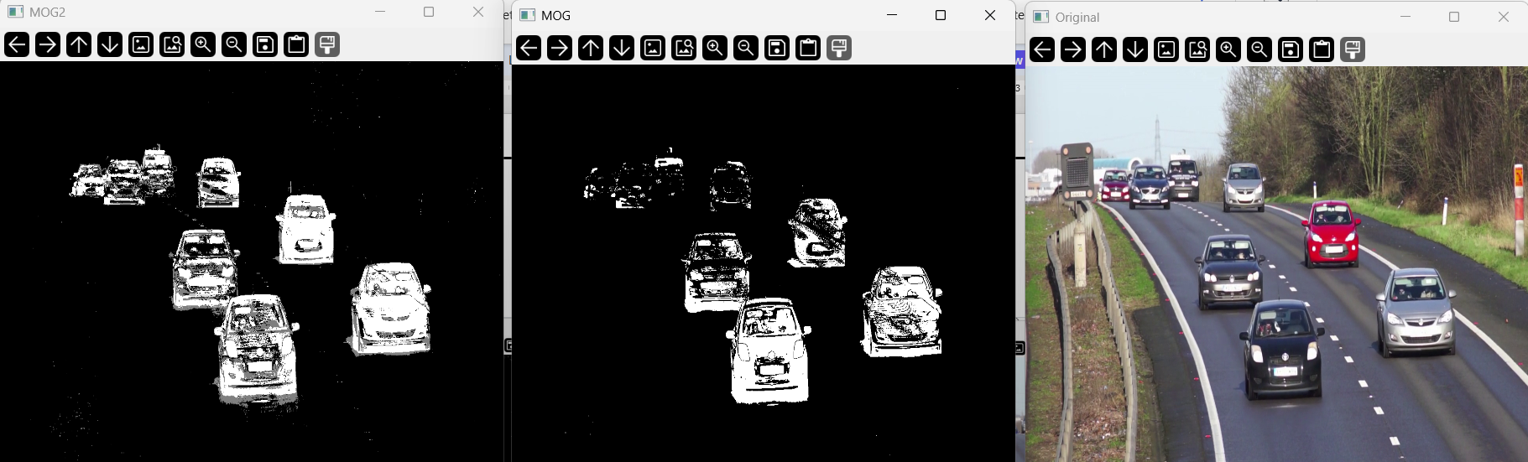

**Background subtraction using averaging:**

1. Initialize video capture using cv2.VideoCapture().
2. Read the first frame and check if the video is accessible.
3. Convert the first frame to grayscale and initialize the background model.
4. Loop through video frames until the video ends:

Convert each frame to grayscale.

Update the background model using cv2.accumulateWeighted().

Compute foreground mask using cv2.absdiff().

Apply thresholding to extract moving objects.

Resize and display the background model and foreground mask.

1. Exit on 'ESC' key press and release resources.

**CODE** :

cap = cv2.VideoCapture(r"C:\Users\haris\Downloads\video.mp4")

ret, frame = cap.read()

if not ret:

print("Error: Couldn't read video")

cap.release()

cv2.destroyAllWindows()

exit()

gray = cv2.cvtColor(frame, cv2.COLOR_BGR2GRAY)

avg_bg = np.float32(gray)

while True:

ret, frame = cap.read()

if not ret:

break

gray = cv2.cvtColor(frame, cv2.COLOR_BGR2GRAY)

cv2.accumulateWeighted(gray, avg_bg, 0.01)

bg_model = cv2.convertScaleAbs(avg_bg)

fg_mask = cv2.absdiff(gray, bg_model)

_, fg_mask = cv2.threshold(fg_mask, 40, 255, cv2.THRESH_BINARY)

small_bg_model = cv2.resize(bg_model, (600, 480)) # Adjust width & height as needed

small_fg_mask = cv2.resize(fg_mask, (600, 480))

cv2.imshow("Background Model", small_bg_model)

cv2.imshow("Foreground Mask", small_fg_mask)

if cv2.waitKey(30) & 0xFF == 27:

break

cap.release()

cv2.destroyAllWindows()

**Output:**

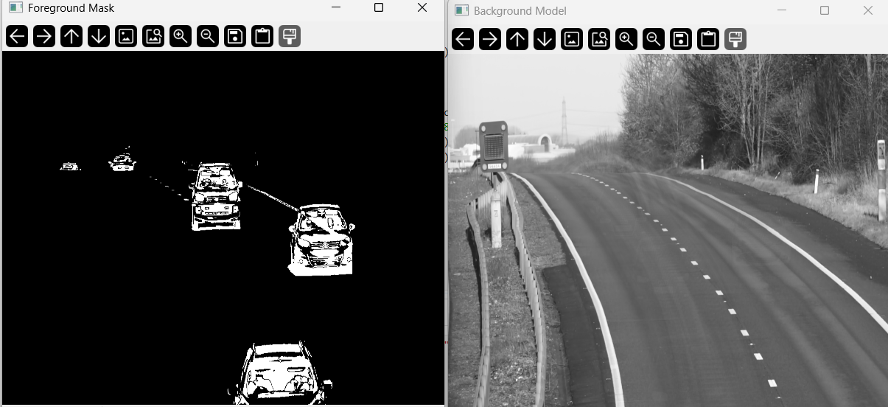

**Scene detection using Background subtraction:**

1. Initialize video capture using cv2.VideoCapture().
2. Create Background Subtractor using cv2.createBackgroundSubtractorMOG2().
3. Read the first frame and check if the video is accessible.
4. Store the first frame as the initial scene.
5. Convert the first frame to grayscale and compute its histogram for comparison.
6. Loop through the video frames:

Convert the frame to grayscale and compute its histogram.

Compare histograms using cv2.compareHist() to detect scene changes.

Apply background subtraction to detect motion and compute change ratio.

If histogram similarity is low & motion is high, mark scene change detection.

If histogram similarity becomes high, mark scene stabilization and save the frame.

Update the previous histogram for the next iteration.

1. Release video resources after processing.
2. Display all detected scene frames using matplotlib.pyplot.
3. Print total detected scenes and complete processing.

**CODE** :

video_path = r"C:\Users\haris\Downloads\mixed.mp4"

cap = cv2.VideoCapture(video_path)

fgbg = cv2.createBackgroundSubtractorMOG2()

ret, frame = cap.read()

if not ret:

print("Error: Couldn't read video")

cap.release()

exit()

scenes = [frame.copy()]

prev_gray = cv2.cvtColor(frame, cv2.COLOR_BGR2GRAY)

prev_hist = cv2.calcHist([prev_gray], [0], None, [256], [0, 256])

cv2.normalize(prev_hist, prev_hist, 0, 1, cv2.NORM_MINMAX)

scene_change_detected = False

while True:

ret, frame = cap.read()

if not ret:

break

gray = cv2.cvtColor(frame, cv2.COLOR_BGR2GRAY)

curr_hist = cv2.calcHist([gray], [0], None, [256], [0, 256])

cv2.normalize(curr_hist, curr_hist, 0, 1, cv2.NORM_MINMAX)

similarity = cv2.compareHist(prev_hist, curr_hist, cv2.HISTCMP_CORREL)

fg_mask = fgbg.apply(frame)

change_ratio = np.count_nonzero(fg_mask) / fg_mask.size

if similarity < 0.5 and change_ratio > 0.3 and not scene_change_detected:

print(f"Scene {len(scenes) + 1} Changed! Waiting for stabilization...")

scene_change_detected = True

elif scene_change_detected and similarity > 0.9:

print(f"Scene {len(scenes) + 1} Stabilized! Saving frame...")

scenes.append(frame.copy())

scene_change_detected = False # Reset flag

prev_hist = curr_hist.copy()

cap.release()

print(f"Total Scenes Detected: {len(scenes)}")

plt.figure(figsize=(15, 5))

for i, scene in enumerate(scenes):

plt.subplot(1, len(scenes), i + 1)

plt.imshow(cv2.cvtColor(scene, cv2.COLOR_BGR2RGB))

plt.title(f"Scene {i + 1}")

plt.axis("off")

plt.show()

print("Processing Complete. All detected scenes displayed.")

**Output:**

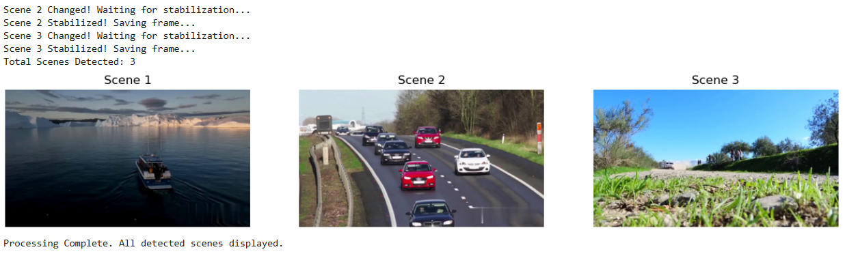

**RESULT :**

Hence , Background subtraction, BDS with averaging and scene detecion has been implemented.

|  |  |
| --- | --- |
| **Exercise No**:12  **Date**:03.04.25 | **Lucas Kanade and KLT Tracking** |

## AIM:

To apply Lucas Kanade algorithm on two frames and for video using KLT Tracking for tracking the

features.

**CODE:**

# Lucas Kanade and KLT Tracking

**import** cv2

**import** numpy **as** np

**import** gdown

**def** read_video(url):

file_id = url.split("/d/")[1].split("/")[0]

download_url = f'https://drive.google.com/uc?id={file_id}' gdown.download(download_url,"video.mp4", quiet=False) **return** cv2.VideoCapture("video.mp4")

**def** play_video(cap):

**while** cap.isOpened():

ret, frame = cap.read()

**if not** ret:

### break

cv2.imshow("Video Playback", frame)

*# Press 'q' to quit early*

**if** cv2.waitKey(25) & 0xFF == ord('q'):

### break

cv2.destroyAllWindows() cap =

read_video("https://drive.google.com/file/d/16czHsa364vmD5lnAHgJRXSTAUFDWLrWH/view?us p=sharing")

Downloading...

From: https://drive.google.com/uc?id=16czHsa364vmD5lnAHgJRXSTAUFDWLrWH To: C:\Users\sanka\PYTHON\COMPUTER VISION\video.mp4

100%|█████████████████████████████████████████████████████████████████████████████|

8.13M/8.13M [00:07<00:00, 1.13MB/s]

play_video(cap)

# Lucas Kanade for Two Frames

**def** lucas_kanade_two_frames(cap): cap.set(cv2.CAP_PROP_POS_FRAMES,0) ret, old_frame = cap.read()

**if not** ret:

print("Failed to read the first frame")

### return

old_gray = cv2.cvtColor(old_frame, cv2.COLOR_BGR2GRAY)

features = cv2.goodFeaturesToTrack(old_gray, maxCorners=100, qualityLevel=0.3, minDistance=7, blockSize=7)

lk_params = dict(winSize=(15, 15), maxLevel=2,

criteria=(cv2.TERM_CRITERIA_EPS | cv2.TERM_CRITERIA_COUNT, 10,

0.03))

mask = np.zeros_like(old_frame) ret, new_frame = cap.read()

**if not** ret:

print("Failed to read the second frame")

### return

new_gray = cv2.cvtColor(new_frame, cv2.COLOR_BGR2GRAY)

next_points, status, _ = cv2.calcOpticalFlowPyrLK(old_gray, new_gray, features, None, **lk_params)

good_new = next_points[status == 1] good_old = features[status == 1]

**for** i, (new, old) **in** enumerate(zip(good_new, good_old)): x_new, y_new = new.ravel()

x_old, y_old = old.ravel()

mask = cv2.line(mask, (int(x_new), int(y_new)), (int(x_old), int(y_old)), (0, 255, 0), 2)

new_frame = cv2.circle(new_frame, (int(x_new), int(y_new)), 5, (0, 0, 255), -

1)

output = cv2.add(new_frame, mask)

cv2.imshow('Lucas-Kanade Optical Flow (First Two Frames)', output)

cv2.waitKey(0) cv2.destroyAllWindows()

lucas_kanade_two_frames(cap)

# OUTPUT:

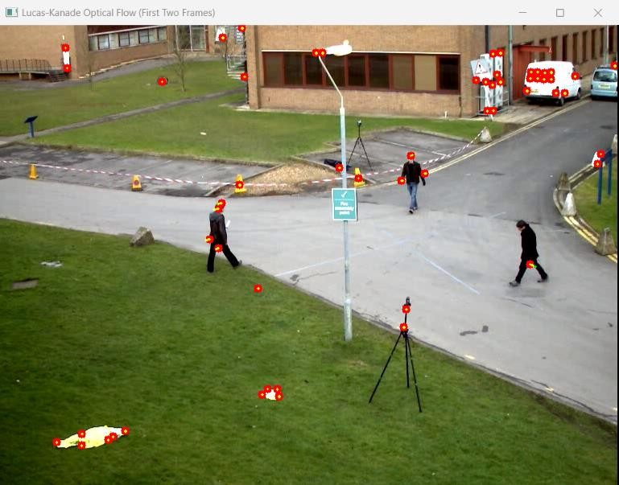

**Lucas Kanade and KLT for Video**

ret, old_frame = cap.read()

old_gray = cv2.cvtColor(old_frame, cv2.COLOR_BGR2GRAY)

features = cv2.goodFeaturesToTrack(old_gray, maxCorners=100, qualityLevel=0.3, minDistance=7, blockSize=7)

lk_params = dict(winSize=(15, 15), maxLevel=2,

criteria=(cv2.TERM_CRITERIA_EPS | cv2.TERM_CRITERIA_COUNT, 10,

0.03))

mask = np.zeros_like(old_frame) cap.set(cv2.CAP_PROP_POS_FRAMES,0)

**while** True:

ret, frame = cap.read()

**if not** ret:

print('Video Finishes')

### break

frame_gray = cv2.cvtColor(frame, cv2.COLOR_BGR2GRAY)

next_points, status, _ = cv2.calcOpticalFlowPyrLK(old_gray, frame_gray, features, None, **lk_params)

good_new = next_points[status == 1] good_old = features[status == 1]

**for** i, (new, old) **in** enumerate(zip(good_new, good_old)): x_new, y_new = new.ravel()

x_old, y_old = old.ravel()

mask = cv2.line(mask, (int(x_new), int(y_new)), (int(x_old), int(y_old)), (0, 255, 0), 2)

frame = cv2.circle(frame, (int(x_new), int(y_new)), 5, (0, 0, 255), -1)

output = cv2.add(frame, mask) cv2.imshow('KLT Tracking', output)

old_gray = frame_gray.copy()

features = good_new.reshape(-1, 1, 2)

**if** cv2.waitKey(30) & 0xFF == ord('q'):

### break

cv2.destroyAllWindows()

## RESULT:

Thus, Lucas Kanade algorithm on two frames and for video using KLT Tracking for tracking the features was written and executed successfully.